Prince Rupert Middle School Plan

**Vision:**  **Achieving Success Together**

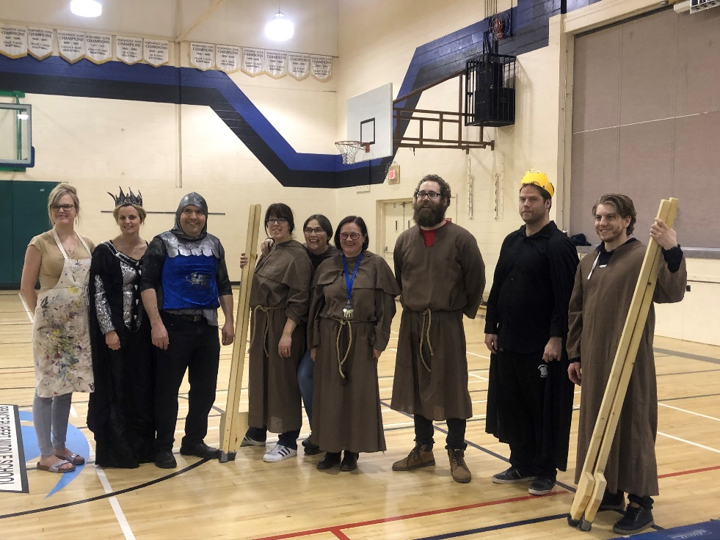

**Mission/Belief:** **At PRMS we believe:**

* Each of us is a unique and creative individual of value to our school community
* We have the right to learn and have fun
* We have the responsibility to treat ourselves and others with respect
* We take pride in our work, our accomplishments, our school building, and our learning tools.

**Smhawksm a PRMS**

* Txa’nii kabatgüüłk a ts’m Wap Suwilaawksa gwa’a int gwin dag̱̱oydiksa smgit goo wulaayt ada dmt łoodit.
* Gałgwasgüüdm wil suwilaawksm.
* Sgüü dm łootm txa’nii goo ada txa’nii gyet.
* Akadziksa gagoodm a goo da’axgm, na hakhałesm a Wap Suwilaawksa gwa’a ada ’nwil hoya hoym wil suwilaaywksm.

**À PRMS nous croyons que:**

* Chacun de nous est unique et créatif et que nous contribuons tous à enrichir notre vie écolière
* Nous avons le droit d’apprendre et de nous amuser
* Nous avons la responsabilité de traiter les autres et nous-mêmes avec respect
* Nous sommes fières de nos travaux, nos talents, notre école et notre environnement

**Context:**

Prince Rupert Middle School (PRMS) is a grade 6-8 middle school located in the City of Prince Rupert on traditional Ts’msyen territory with a diverse multicultural mix. The current enrollment of PRMS is around 415 students of which 65% are of Aboriginal ancestry. Our staff is over 50 professionals including 2 administrators, 2 school counselors, 2 family aboriginal resource workers, teachers and educational assistants. PRMS is a dual tract school with a French Immersion Program and offers Sm’alygyax and French as second language courses. PRMS is the first Middle School in Prince Rupert. In its eighth year, PRMS will continue to focus on developing a Middle School culture of collaboration and respect which focuses on our PRMS beliefs. It will also begin to target some areas of concern, specifically literacy and social responsibility.

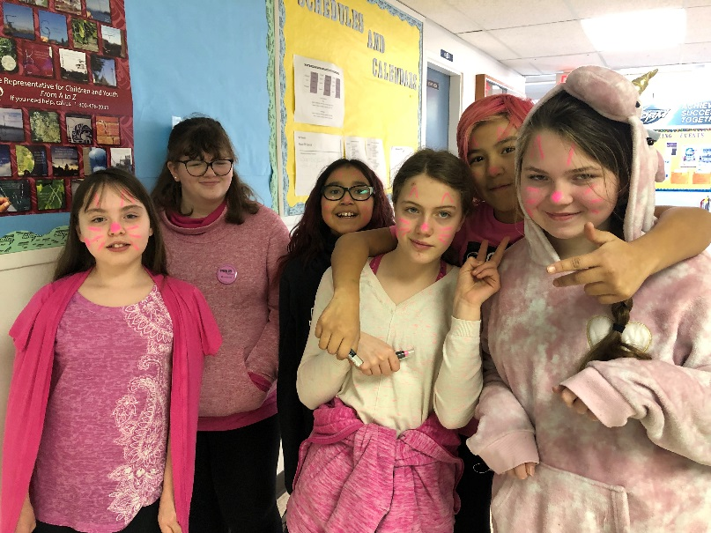

**Goal(s)**:

1. Literacy – If we focus on teaching literacy in all subject areas, and provide direct and intensive instruction to students that would benefit from it, can we increase the percentage of students reading and writing, at or above grade level?
2. Personal and Cultural Awareness and Communication, Personal awareness and Responsibility, and Communication– Specific goal for each grade;

* If we teach and assess using core competencies, will we see an improvement in pride in ones self and respect for others? (grade 6)
* If we teach and assess using core competencies, will we see an improvement in students’ cultural awareness and respect for other cultures and beliefs? (Grade 7)
* If we teach and assess using core competencies, will we see an improvement in students’ cultural awareness and respect for other cultures and beliefs? (Grade 8)

Social Responsibility – Specific goal for each grade;

* If we teach and assess using core competencies, will we see an improvement in behaviour and increase in empathy? (grade 6)
* If we teach and assess using core competencies, will we see an improvement in behaviour and respect for others? (grade 7)
* If we teach and assess using core competencies, will we see an improvement in behaviour and respect for self? (grade 8)

Communication

* If we teach and assess using core competencies, will we see an improvement in student’s ability to communicate with each other and with adults?

**Structures and Strategies**:

1. Literacy

* LST and ELD co-planning and co-teaching in classrooms.
* Teacher collaboration for grade level units and lesson
* Grade 6 Reading groups
* Library Prezi’s to promote Literacy
* 6 Minute Solution
* Adrienne Gear Strategies
* Celebration of Reading pictures posted within the school
* Guided reading across classrooms

1. Personal and Cultural Awareness and Communication

* Positive Behaviour Support change model
* School wide shared matrix to promote language used to increase positive behaviours within the school
* Grade group focus to scaffold Personal and Cultural Awareness and Communication goal from grade 6 through to grade 8
* Student led groups to increase personal and cultural awareness and communication: Kindness Club and Leadership
* Developing lessons to explicitly teach personal and cultural awareness goals at each grade level
* Explicitly teaching students how to self-assess using the core-competencies
* Promoting peer-tutoring roles to increase personal awareness
* School wide cultural events; Lion Dance, Carnaval, Aboriginal Day, Crests and Clans units, totem pole unit, arts and mentorship programs.
* School wide focus on “We Believe” statements

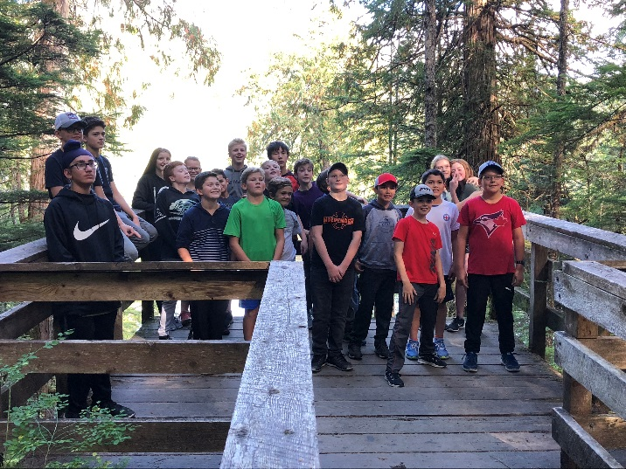

**Plans for Staff Development**:

* Autism workshops
* Regular weekly collaboration
* Cross-Currents Professional development
* PITA Professional Development
* Maker Day Staff workshop
* Mental health workshop
* Time to collaborate and follow up after Pro-d implementation to promote the learning opportunities
* Trauma Informed Practice – Implementation Day
* Cris Rowan and technology awareness
* District Professional Development Conference (November)
* Math Ts’msyen lessons

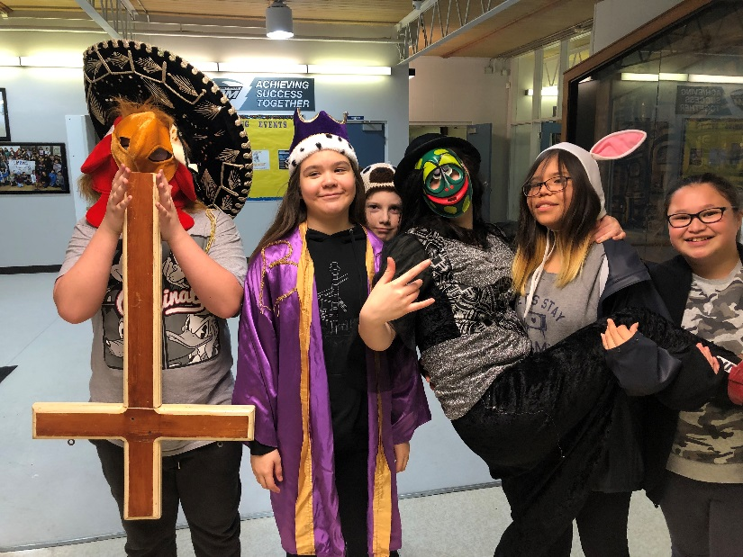

**Community Involvement:**

* Working with the PAC to host family fun nights to increase parental comfort with the school
* Students working with the community to fundraise for SPCA
* Students seeing a need in the community and raising awareness
* Leadership providing community activities
* Role model guest speakers
* Neighbourhood clean-up events
* Working with the Port – Great Shoreline Clean-up events and other initiatives
* Helping out in the community with Salvation Army warm breakfasts

**Communication:**

* SIP is shared with parents at PAC meetings
* SIP developed through team leader meetings, grade group meetings, and staff meetings
* SIP will be placed on website for parents to read

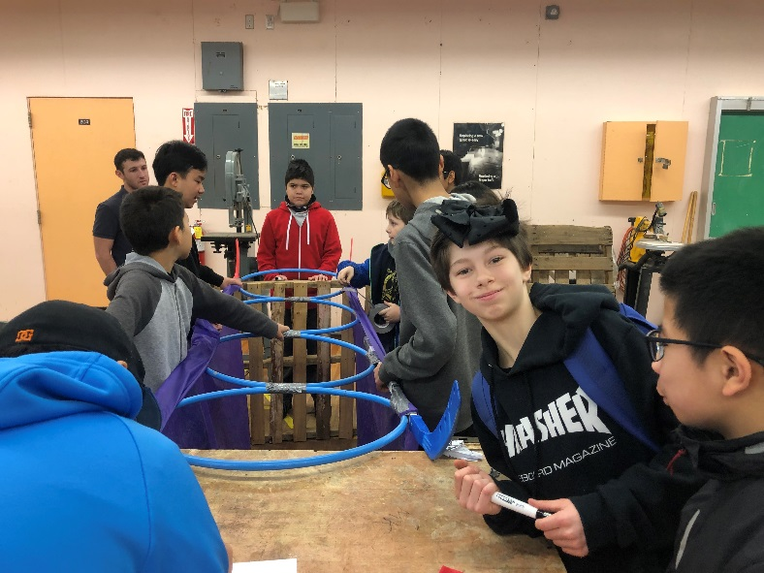

**Evidence**:

* Benchmark reading levels
* Performance Standard rubrics
* Teacher tracking and observation
* District Framework Survey Results
* MDI Survey Results
* Office Referrals
* Student comments and/or attitudes
* TTOC and guests to the school, comments and observations
* Comments/observations from hosts during visits outside of the school
* Parent comments on changes in students personal/social awareness
* Comments from staff on progress with students helping others and inclusion

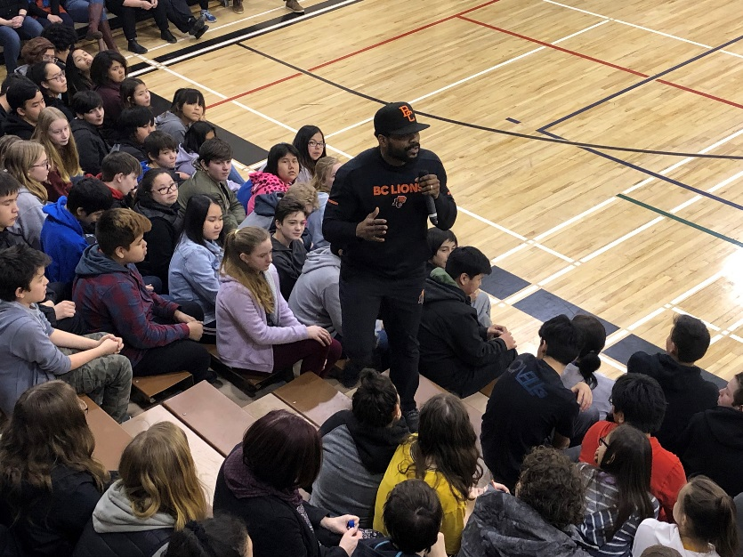

**Reflection and Summary:**

**Professional Development**

* PRMS teachers attended the District Professional Development Conference in November
* Trauma Informed Practice Implementation Day all PRMS staff attended
* PRMS support staff took part in Non-violent crisis intervention and prevention training
* Training on Autism through POPARD
* Cris Rowan Technology awareness professional development in April
* Counsellors attended Jack Hirose conference on mental health and inclusion
* LST and Admin attended Down Syndrome Conference on Inclusion and strategies to support all students
* Aboriginal Education Symposium

**Community**

Ms. Ragan, Ms. Proskiw’s, and Ms. Murphy’s classes joined the Port of Prince Rupert in the annual Great Shoreline Clean up event in October. The class collected over 500 kg of garbage.

The grade 6 class students fundraised for the SPCA. This was done with cupcake bake sales.

The band played in the community winter concert as well as caroling throughout the community and in the Seafest Parade

PRMS hosted a Family Craft Night in December

PRMS hosted a welcome to Middle School evening in May

PRMS Hockey Academy took part in running three pancake breakfasts with the Salvation Army

PRMS celebration assembly and talent show

**Evidence**

**Benchmark reading levels –** Students working with LST or ELD teachers are assesses using the Benchmark assessment at the beginning and the end of the year.

**Fluency –** LST teachers set up the 6 minute Solution Reading Fluency program in most of this year’s classes. Students school wide showed growth in fluency levels.

**Grade 6 Reading Groups –** This year grade 6 students participated in reading groups in both terms one and two.  Students were grouped based on their individual reading level and received instruction designed to help them develop and grow as readers.  Groups were generally smaller than class sizes as Learning Services Teachers also took groups.  Overall teachers were pleased with the results noticing improved skills and increased confidence in students especially those who read below grade level.  As well students who read above grade level were provided with a challenge.  Grade 6 teachers plan to continue this project next year.

**Performance Standard Rubrics –** Grade 8 teachers designed a book report assignment that was completed by all grade 8 students. Students were given a rubric created from the Performance Standards on how their assignment would be assessed. The assignment was created so that all students would be able to complete the project. Performance Standards were also used with many projects across the grades.

Grade 8 English teachers found that the book report assignment was a success and students demonstrated a growth in Literacy skills from the beginning of the year. Teachers were surprised that all students were able to complete the assignment. Students were aware of the expectations for the assignment from the rubric that they were provided. Teachers made accommodations in choice of novel and framework of project for certain students that required this.

**Teacher Tracking and Observation**

For next school year, we will need to come up with a better method for collecting teacher observations. One method we could use would be a teacher survey at the beginning and at the end of the year. Another method we could use is pre and post assessments using the performance standards. We would also like to include tracking of information from the MDI survey and from student self assessments of core competencies.

**Grades 6-8 Framework Survey June 2019**

**Goal 1 -To develop an appreciation of reading**

**Goal 2 – To enhance student application of numeracy**

**Goal 3 – To explore the BIG Ideas**

a) Through Aboriginal Perspectives and other local issues.

b) To promote a love of learning through problem and project-based opportunities.

**Goal 4 – Our schools are places where students, families and staff all feel a sense of belonging.**

**Goal 5 – To ensure every student can identify multiple, positive relationships they have with peers and staff within the school community.**

**Goal 6 – Purposefully teach prosocial skills and provide opportunities to practice.**

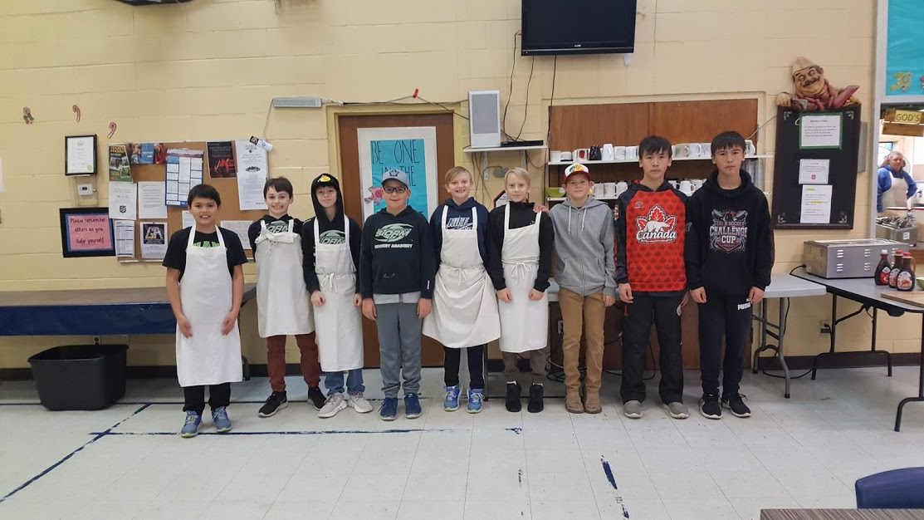

**MDI Middle Years Development Instrument Survey Results:**

**Well-Being Index:**

The Well-Being index combines the MDI measures relating to student’s physical health and social and emotional development.

**High Well-Being (thriving):** Students who scored in the high range with at least 4/5 measures of well-being and have no low-ranged scores.

**Medium Well-Being:** Students who scored in the high range with fewer 4 measures of well-being and have no low-ranged scores.

**Low Well-Being:** Students who scored in the low range with at least 1/5 measures of well-being.

**Assets Index:**

The Assets index combines MDI measures that highlight four key assets that help to promote children’s positive development and well-being.

**Next Steps:**

**Things to Celebrate**

Our Band received invitations to Music Fest Canada with their performances at the Pacific Northwest Music Festival.

The Grade 8 Boys Basketball team won zone playoffs.

Grade 8 students attended track and field provincials.

PRMS students participated in the district Sphero Olympics, district Bridge building competition, and the Pacific Northwest Regional Science fair with one member qualifying for the Canada-Wide Science fair.

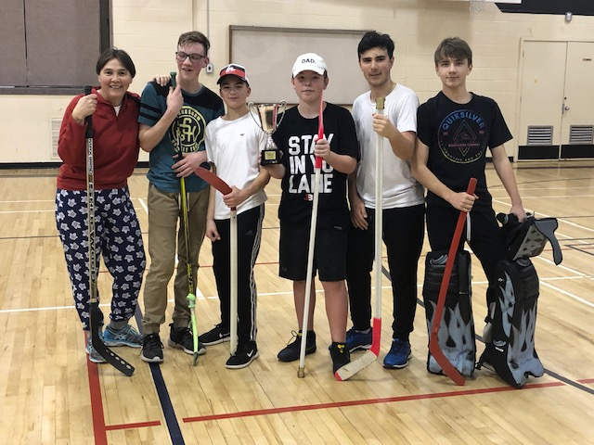

**Self Assessments**

**Student Self-Assessment Personal and Cultural Awareness – Grade 6 (2018)**

|  |  |  |  |  |
| --- | --- | --- | --- | --- |
|  | **Always** | **Usually** | **Sometimes** | **Rarely** |
| **I can name some of my traits.** |  |  |  |  |
| **I can express what interests me and my likes/dislikes** |  |  |  |  |
| **I am aware of myself as different from others and respect that others are different from me.** |  |  |  |  |
| **I have pride in who I am.** |  |  |  |  |
| **I know how my choices reflect who I want to be.** |  |  |  |  |
| **I know learning is lifelong and I will continue to grow and change.** |  |  |  |  |

**The trait I am most proud of is ______________________________ and I show it**

**by ________________________________________________________________**

**A trait I will work to improve is ________________________________________**

**I will do this by ______________________________________________________**

Personal and Cultural Awareness and Communication  
Grade 7

Name: ___________________________

|  |  |  |  |  |
| --- | --- | --- | --- | --- |
|  | I don’t do this yet. | I do this some of the time. | I usually do this. | I always do this. |
| I know how I am unique from my peers. |  |  |  |  |
| I can describe myself as a member of my family and/or loved ones with pride. |  |  |  |  |
| I understand how my family, history, life experiences, family background, peers, and values shape who I am. |  |  |  |  |
| I know who I am and I understand how my strengths can help me to be a leader. |  |  |  |  |
| I see how I can improve and better myself. |  |  |  |  |
| I understand how my actions and words impact others. |  |  |  |  |

Cultural Responsibility

Self-Assessment – Grade 8 (2018)

|  |  |  |  |  |
| --- | --- | --- | --- | --- |
| Questions | Circle which of the four options most closely applies to you. | | | |
| Cultural Awareness | I know where I come from culturally. | I know where I am going in my culture. | I will be a leader in my family. | I will be a leader in my community. |
| Cultural Pride | I fell a sense of personal pride. | I feel a sense of pride in my social group. | I feel a sense of pride in my family. | I feel a sense of pride in my community. |
| When I am around my friends… | …I follow along with what they do. | …I can disagree with my friends. | … I make my own choices. | …I make my own choices after consulting with others. |
| Who I am is… | …my name and my family | …where my family comes from. | …my past and how my past influences. | …something that I can change based on what I choose to do with my life. |

Describe the person you want to be.

**Student Self-Assessment Personal Awareness and Responsibility Grade 6 (2017)**

**Name________________**

|  |  |  |  |  |
| --- | --- | --- | --- | --- |
|  | **Always** | **Usually** | **Sometimes** | **Rarely** |
| **I am focused during work time.** |  |  |  |  |
| **When I become angry or upset I am able to calm myself.** |  |  |  |  |
| **I can take responsibility for my physical and emotional well-being.** |  |  |  |  |
| **I take pride in my work.** |  |  |  |  |
| **I take care of our school building and learning tools.** |  |  |  |  |

**I can show responsibility by____________________________________________**

**___________________________________________________________________**

**___________________________________________________________________**

**___________________________________________________________________**

**I can improve by ____________________________________________________**

**__________________________________________________________________**

**___________________________________________________________________**

**_____________________________________________________________**

Respect for Others (2017)

Grade 7 - Student Core Competency Self-Assessment: Personal Awareness and Responsibility

|  |  |  |  |  |
| --- | --- | --- | --- | --- |
| Situation | 1  not yet meeting expectations  (Rarely) | 2  Minimally meeting expectations  (Some of the time) | 3  Fully meeting expectations  (Most of the time) | 4  Exceeds expectations  (Always) |
| When an adult in the school asks me to do something, I immediately comply. |  |  |  |  |
| I listen to my peers/classmates without interrupting. |  |  |  |  |
| I make sure that any area I use in the school is left in the same or better condition than when I found it. |  |  |  |  |
| I follow school rules. |  |  |  |  |
| I am mindful before I speak that what I am about to say is kind and respectful. |  |  |  |  |
| I am aware of the real-life consequences of my online actions. |  |  |  |  |

I show respect by:

|  |  |  |  |  |
| --- | --- | --- | --- | --- |
| Questions | Circle which of the four options most closely applies to you. | | | |
| When I don’t understand something and need help I…. | ….wait for someone to come along and help me. | Ask for help by saying “I don’t get it” | Ask for help by saying “I tried this but it doesn’t seem to work. What am I doing wrong?” | Search my notes or read up on a topic and then try several solutions before asking for help about a specific situation. |
| When I know something I… | …keep quiet. | …mention what I know to someone next to me or a friend. | …share what I know with people around me. | …ask for an opportunity to share what I know with people. |
| I show up to school because… | I have to be here and get in trouble if I don’t. | I have to be here because I know that school is important. | I know that school will let me get a good job when I’m older. | I have a specific career goal that needs the skills I get in specific classes. |
| When I do something wrong I… | …say nothing and hope that no one notices. | ….say nothing but try to fix it before anyone notices. | …say something but don’t really try to fix it. | …say something and apologize while trying to make amends. |

Grade 8 Self-Assessment (2017)

What does it mean to be prepared for class?

Communication Self Assessment – Grade 7

**Learning Journal: Core Competency Self-Assessment**

**Communication**

□ Give an example of when you shared information that made your group “smarter”

□ Tell a time when you disagreed and let them know in a respectful manner.

□ What kind of feedback helps you learn?

□ Tell a time you used feedback to improve your learning

□ What does effective group work look like?

□ What strategies do you use to help you present information in an organized manner?

□ How do you share information with others?

□ Describe some ways you have collaborated with others.

□ How do we communicate effectively? Looks like, Sounds Like, Facts Like

□ How do you show you are an active listener?

□ What is my role in Group work? And how do I connect and engage with others?

□ What is your strength in group work?

□ What do you need to?

□ What role is easy for you? Hard for you?

□ How do I acquire/interpret or present info (focus on one at a time)

□ What is the purpose of collaboration?

□ Think of a time you presented to others. What worked well? Was important to do? 3 stars plus

a wish

□ Think of a metaphor that show who you are as a listener, learner, communicator

□ What could you do differently?

□ Know what you know now about

□ What would you do differently?

□ How did you work with others to develop ideas…to create solutions?

□ In what ways did your listening contribute to the group’s understanding?

□ What do you do when you disagree?

□ What strategies do you use to generate ideas?

□ What are some strategies you use to present information clearly and in an organized way?

□ How do you use the language of discipline to articulate your learning?

□ What are some ways you can show your learning?

**Student Self-Assessment Communication – Grade 6**

|  |  |  |  |  |
| --- | --- | --- | --- | --- |
|  | **Always** | **Usually** | **Sometimes** | **Rarely** |
| **I ask and respond to simple and direct questions.** |  |  |  |  |
| **I present information clearly and in an organized way.** |  |  |  |  |
| **I recognize that there are different points of view and I can disagree respectfully.** |  |  |  |  |
| **I can take on roles and responsibilities in a group; I do my share.** |  |  |  |  |
| **I can tell about what I’ve learned, and when given suggestions to improve make changes in my work.** |  |  |  |  |
|  |  |  |  |  |

**I show good communication by _____________________________________**

**________________________________________________________________**

**________________________________________________________________**

**________________________________________________________________**

**I can improve my communication_____________________________________**

**_________________________________________________________________**

**_________________________________________________________________**

**_________________________________________________________________**

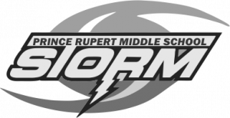**Communication Self Evaluation Gr. 8**

|  |  |  |  |  |
| --- | --- | --- | --- | --- |
| Question | Circle which of the four options most closely applies to you | | | |
| During classroom discussions, … | I rarely pay attention, and I am unsure of what people think. | I respond to direct questions but I rarely ask for anyone else’s opinion. | I listen carefully to others and respond to them vociferously (strongly.) | I express my ideas clearly and can disagree respectfully with other points of view. |
| When asked to research and present information, … | I will not speak in front of others. | I can understand and give information if the topic is important to me. | I can present information clearly to people that I know. | I can present information confidently, in an organized way, even to people I don’t know. |
| When asked to work in a group, … | I sit with the group and may listen, but I don’t contribute to the work. | I can work with others and do my share. | I take an active role in the group and listen to the ideas of others. | I can take the ideas of others and summarize them clearly. |
| When asked to explain why I got a particular grade on an assessment,… | I remember some marks but did nothing differently. | I read the feedback and try to improve. | I remember some examples of feedback and can explain what I learned from them. | I can explain how my grade reflect my work and know how to improve it next time. |

**Grade 8**

What are the important characteristics of a good presentation?

____________________________________________________________________________________________________________________________________________________________________________________________________________________________________________________________________________________________________________________________________________________