Pineridge School Plan
2019-20

Mission: Combining potentials for lifelong learning.
This year, our staff has worked to enhance the literacy development of our students, as well as continuing to build a positive school climate where students feel comfortable and connected to the adults that work with them. The values of respect, empathy, growth and humour continue to lead the way and guide our interactions with students as we support them in their learning. We believe in supporting both social–emotional and academic development in our students. We want to see personal growth for each of our students, as well as help them to develop a growth mindset. Teachers have worked with their classes developing their unique set of classroom beliefs, and this information has been taken into account for our school-wide beliefs. Our school beliefs are:
Pineridge School Beliefs
- We keep our school safe and caring
- We respect ourselves, each other and the environment
- We take responsibility for our learning

(Please see appendices at the end of this document for the more detailed explanation.)

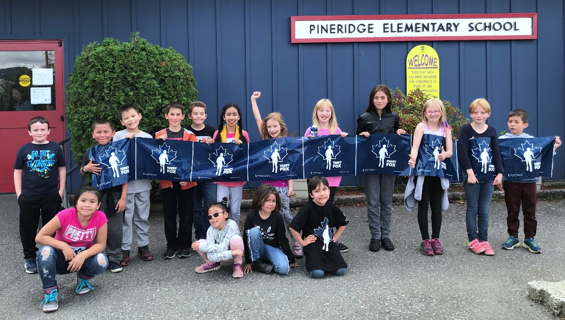
Terry Fox Run
Context:
Pineridge Elementary School is a Kindergarten to grade 5 school situated in Ts’msyen territory and currently approximately 67% of the approximately 160 students are of Aboriginal ancestry. There are a variety of Aboriginal groups in our student body including: Ts’msyen, Haida, Haisla, Nisga’a, and Gitxsan. Our students and families are diverse in terms of culture and what is important to them, and our school embraces diversity and promotes inclusion. We try to provide many opportunities for hands-on learning, such as STEM (Science Technology Engineering and Math) projects, and Outdoor Classroom time, where many classes take advantage of the beautiful natural surroundings, including Moresby Pond.
The building is a one level school (no stairs) located on the west side of the school district and we are able to accommodate students with mobility challenges. There is a Strong Start Centre, as well as before and after school daycare located at Pineridge. We have an accessible playground that our PAC and School District 52 worked very hard to fundraise for. This year, with fundraising from the PAC and numerous community donations, we were able to install two new playground pieces, which was very exciting for our students!
Goal(s):
#1 Every student at Pineridge Elementary will improve their literacy skills and develop further joy in reading.
Objectives:
- Every student improves in their reading scores by one or more grade levels.
- Every student who is not yet reading at grade level receives appropriate intervention to improve their reading scores by one or more grade level.
#2 Students will develop characteristics of resiliency i.e. creativity, flexibility, effective decision-making, ability to solve problems, ability to work collaboratively with others, have positive connections to adults and feel they belong to the school community.
Structures and Strategies:
Goal #1:
- School-Wide Literacy blocks where classroom teachers work with non-enrolling teachers (Learning Services Teachers, ELD Teacher and principal) to provide instruction and practice at students’ literacy level, including early literacy intervention, guided reading, literature circles and literacy centres
- Extra practice and support provided in focused areas for students i.e.: vocabulary, fluency and/or comprehension (within classrooms)
- Learning Services: Direct and consultative support for struggling readers
- RAISE: Reading Assessment Intervention Systematic Evaluations: small group instruction on phonological awareness for struggling students. The focus is on practice with one skill at a time and students are regularly assessed (weekly or bi-weekly)
- Technology: use of I-pad and appropriate apps for some students with learning disabilities and/or communication support
- Continuing to develop our library, so that it is a vibrant and exciting place where students can continue developing their love for books and learning
- Library Instruction: has included a wide variety of topics and skills including how to use the library, literacy strategies, research, technology, etc.
- Chocolate Lily Awards: Supported by our librarian, students have participated in reading, discussing and voting on their choices for the BC Prize Picture Books contest. There was lots of interest and excitement about these stories!
- POPS (Parents of Primary Students): Reading session
- PALS (Parents as Literacy Supporters): Writing, ABC’s
- Literacy activities embedded in experiential learning i.e. STEM projects, outdoor learning
- Buddy reading, visiting authors, Book Fairs, Read With the Rampage
- Additional literacy resources: Strong Nations series, new guided reading books, big books, etc.
- District Early Intervention Plan: K and gr. 1 students this year, in-service was provided, assessments were done for both grades, one short block of intervention was done for gr. 1 students at risk
- District Literacy Teacher: worked with staff providing direct literacy support, doing literacy assessments (K and gr. 1) and providing direct Early Literacy Intervention for at-risk gr. 1 students.
- Parent Volunteer: reads with students 2 times weekly
- Love to Read Week: both PAC and staff planned an exciting week to promote love for reading including a fund-raiser going towards updating our primary book bins, incentives for students who are reading, Book Swap and pajama day/read-a-thon

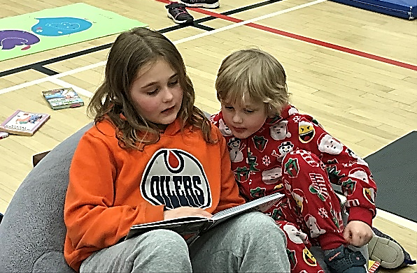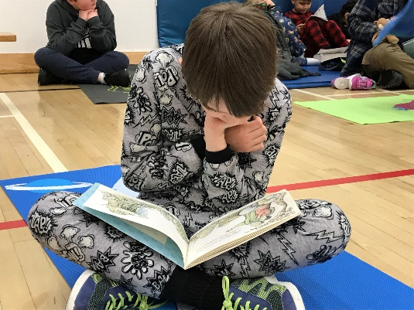
Goal #2:
- Many classes have older/younger buddies and they work together to build relationships, as well as develop both social/emotional and academic skills.
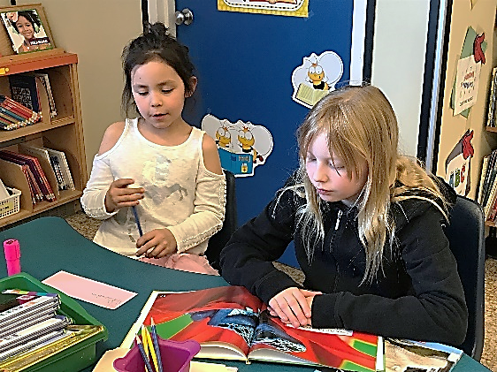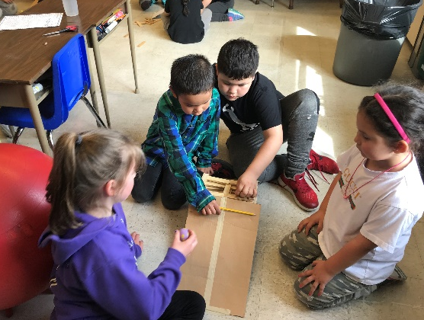
Buddies reading and building together

- ADST: embracing the Applied Design, Skills and Technologies curriculum. These activities foster collaboration, creativity, planning and problem-solving, as well as a sense of pride in accomplishment while providing access for all students (ie: Christmas Cardboard Challenge, STEM activities in classrooms, coding, ozobots, spheros, Sphero Olympics, collaborative STEM activities with librarian, Pals Tiny Techies session, etc.).
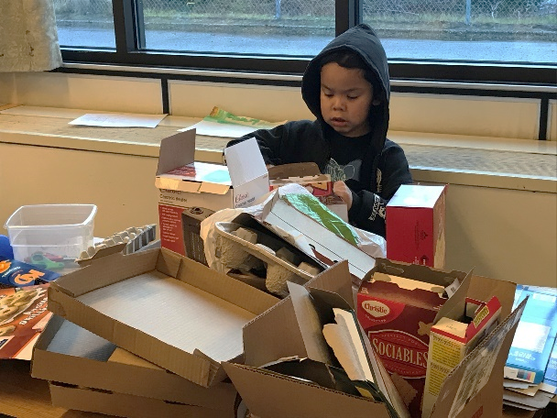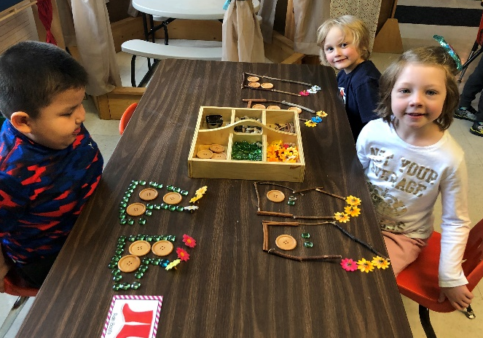
Cardboard Challenge Loose Parts
- STEM (Science, Technology, Engineering and Math) projects continue to be embedded into instruction in many classrooms. (ADST) STEM activities are also embedded into most of our school wide Fun Days.

- Outdoor Education: many of our classes continue to go outside on a regular basis, often to Moresby Pond, and sometimes for a walk in the playground or neighbourhood. This is the Outdoor Classroom where students are involved in a number of activities. They may be learning about the outdoors, connecting to place, making connections to aboriginal ways of knowing and learning, exploring Math or Science, gathering inspiration for art, reading and writing, as well as other open-ended activities. The learning is endless! Through these experiences outside, students are being provided opportunities to communicate, problem-solve, make decisions and build relationships and connections to peers and adults. This year, we once again held a school-wide Outdoor Classroom Day.

- Outdoor Classroom Day: This was a very successful day! Everything was outdoors, including lunch! There was a scavenger hunt at Moresby Pond for plants, outdoor activities on the playground, nature inspired art projects, and all students painted stones inspired by the book “Only One You”, which are being put in the front of our school.

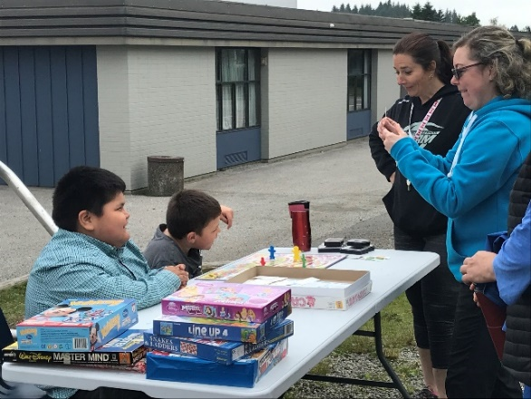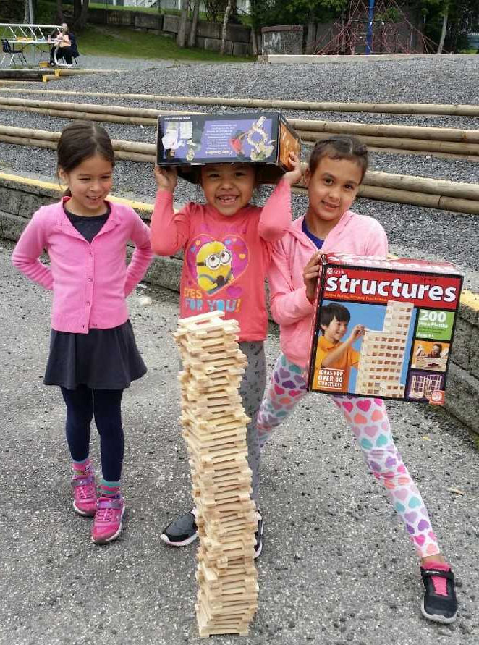
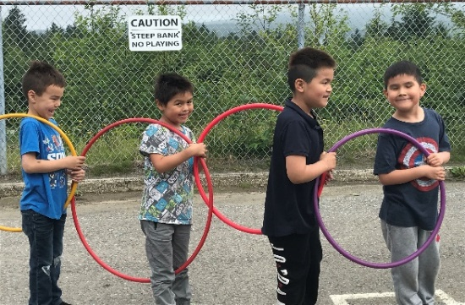
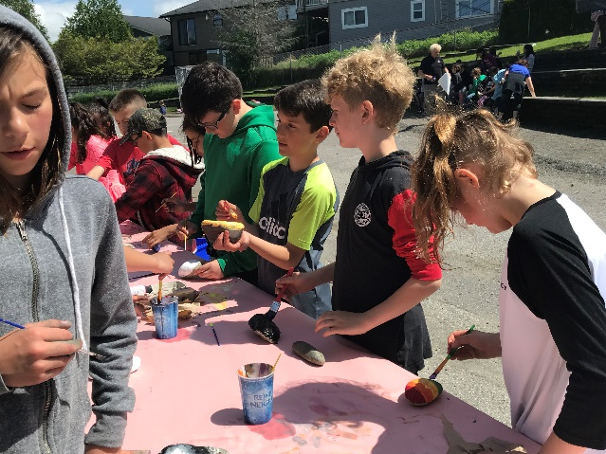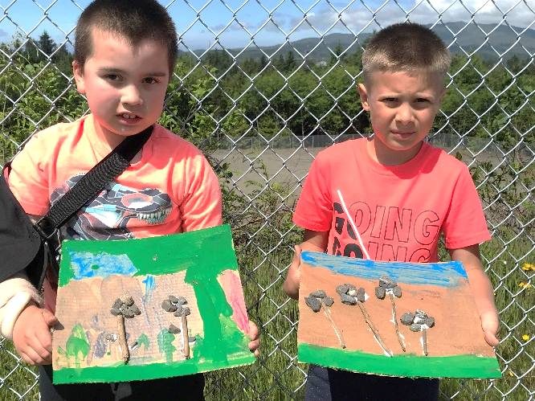
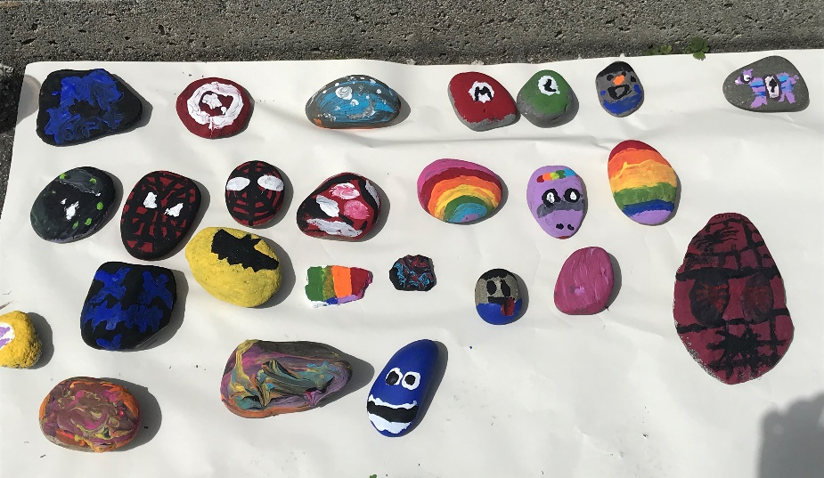
Outdoor Classroom Day

- Social/Emotional Learning and Strategies: doing kind acts for others, Fill Your Bucket, WITS (Walk away, Ignore, Talk it Out, Seek help), Zones of Regulation, OT working with some classes on self-regulation, Green Shirt Day, Orange Shirt Day to bring awareness of the effects that residential schools have had on our Indigenous Families, Pink Shirt Day with emphasis on being kind to others and celebrating differences, etc. Leading up to Pink Shirt Day, classes payed it forward by surprising other classes with kind acts.
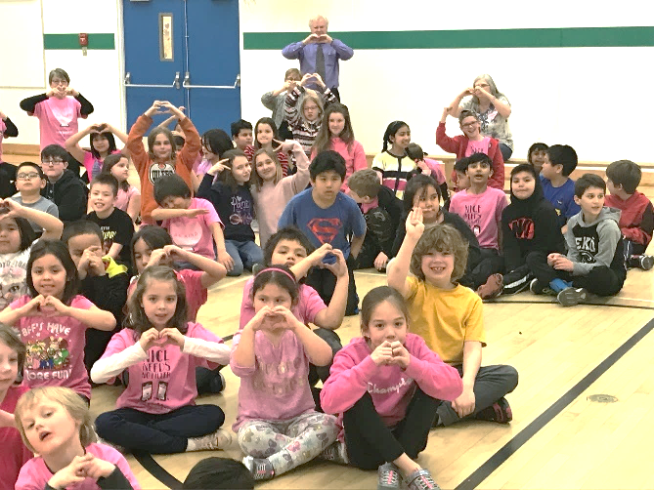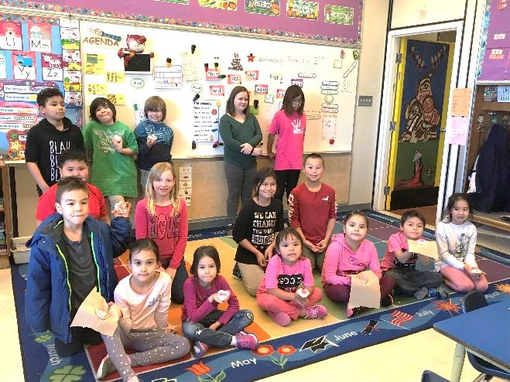
Pink Shirt Day

- White Hatter presentation: grade 4/5 students attended this presentation which provides some fundamentals that students need to be familiar with in today’s world and builds confidence in students using technology safely. Concepts covered included: understanding the realities of technology, concepts of privacy, security and cyber bullying

- Self-Regulation Hallway Path: Staff saw a need for students to have some kind of area for self-regulation. The Occupational Therapist developed a hallway pathway specifically designed for students to use to help regulate. It has multiple ways to use it and was well used both while students were going down the hallway and with specific students needing a movement break. We are working with maintenance to look at making it permanent.
- School Wide Fun Days: Halloween Fun Day, Love to Read Week (home reading, pajama day, read-a-thon, and book swap), Christmas Cardboard Challenge, Outdoor Classroom Day, and Indigenous People’s Day Celebration, and a field trip to Diana Lake for the whole school. For many students, it was the first time they had been to the lake and they had a blast! It was also wonderful to see all the families that joined us as well! These days help to develop a sense of trust and community, including developing positive relationships between staff, students and families, not to mention fun!
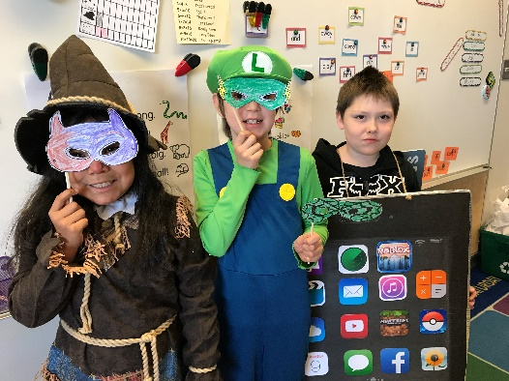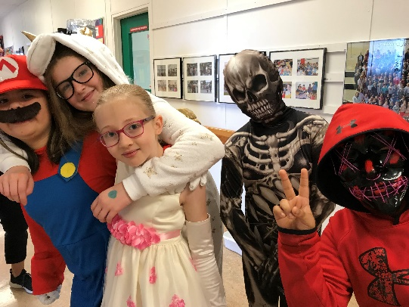
- Science Fair, Heritage Fair and Bridge Building: all these projects help students to develop the core competencies of creative thinking and problem-solving, collaboration and perseverance.
- Drumming: this was a great opportunity for all of our students to feel pride and confidence.

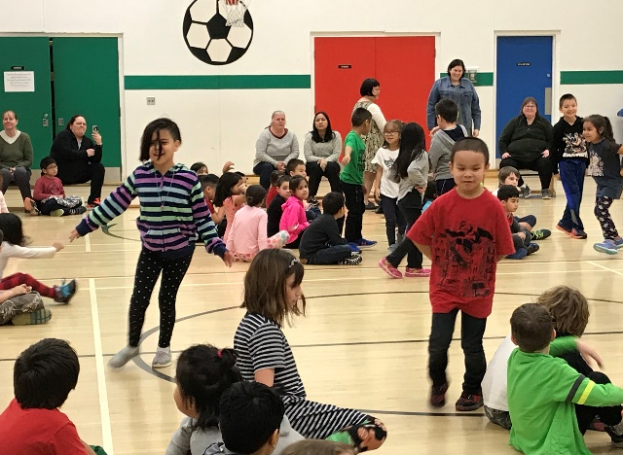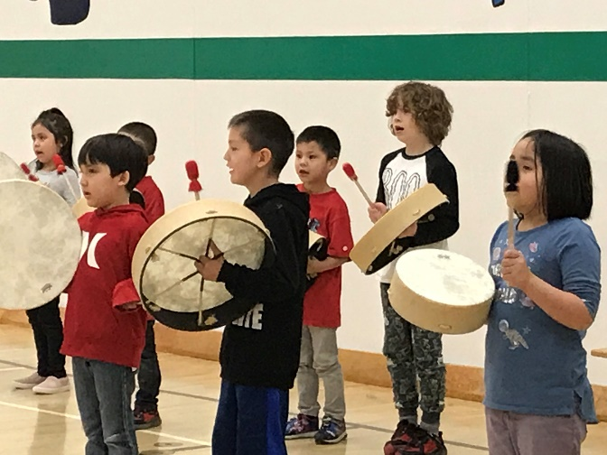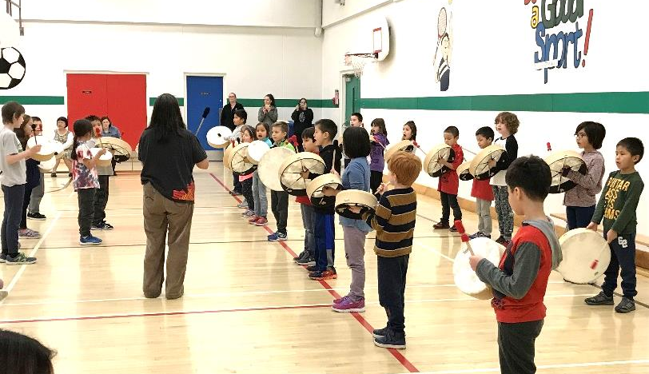
Drumming at the monthly assembly

- Role Models from the Aboriginal Education Department came to our classrooms and built connections with students, as well as helped them learn about various topics, ie: weaving in Sm’algyax class.

- Connecting to culture: Many experiences throughout the year helped students connect to culture. Author Nicola Campbell visited our school to talk with our older students, Gr. 4-5’s in Sm’algyax class worked hard on presenting First Nations readers’ theatre plays. Indigenous People’s Day Celebration was a great success and as always drumming is a highlight for our students.
Plans for Staff Development:
- Many staff have participated in district professional development and implementation opportunities on a number of topics such as: Carole Fullerton (math), Pia Escadero (trauma informed practice and safe schools), Faye Brownlie (literacy), Lori Jameson Rog (literacy), Cris Rowan (Unplugged), CAN Canucks Autism Network (positive behaviour support), Barb McBride for Early Literacy Intervention, Primary Teacher association sessions, etc.
- Prince Rupert’s Indigenous People’s Symposium: many staff attended this conference and participated in a number of valuable workshops presented by colleagues in the district. Ideas and thoughts were discussed at a staff meeting.
- Our staff meetings have addressed the topics of: providing effective feedback, 6 Cedar Trees resource and the Core Competencies, Technology/ADST, reviewing fall student learning surveys, literacy (how are our students doing and how can we support them?), reviewing School Improvement Plan, and also sharing from professional development workshops (ie: Unplugged, Positive Behaviour Support, Indigenous Symposium, First People’s Principles of Learning, Cross Currents Special Education Conference).
- PRDTU Inquiry project: 2 staff participated in this project, focusing on early literacy and how reading daily with and making daily personal connections with students will affect their growth in literacy.
- Weekly Collaboration opportunity (one hour) has been available for teachers to meet, and flex funds have been available as well.
- Resources purchased, shared and discussed from Strong Nations: new social studies books and kits, 6 Cedar Trees resources (books and posters).

Community Involvement:
- PALS and POPS sessions for families
- Volunteer members of Rupert Rampage reading with students
- Salmon Enhancement Project: Fish Hatchery
- Terry Fox Run
- Class went to Acropolis Manor to sing
- Role models coming in to the classrooms to share their knowledge and expertize
- PAC sponsored Love to Read Week in February, PAC monetary support to purchase resource bins on the topics of student inquiry and STEM.
- PAC continuing to fund raise funds and make grant applications to install rubber matting for our two new pieces of playground equipment.
- PAC sponsored Pancake Lunch: a very memorable event!

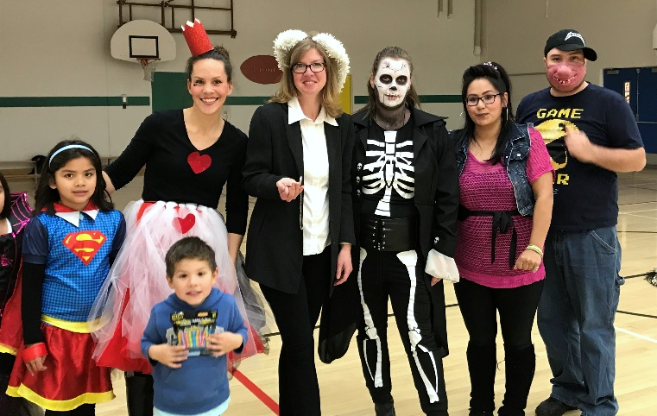
Parent volunteers for Halloween Fun Day

- Trustee participation in PAC meetings
- DFO drain project with older classes
- We are thankful for all our parent and community volunteers who have helped us with activities such as: teaching music, reading with students, helping with Heritage Fair, making survival bracelets with students, coaching basketball and making fried bread for students and staff on Pineridge’s Indigenous People’s Day Celebration
- Many class and school field trips: Cannery, library, swimming, museum, Good-Time Games, Dianna Lake
- Grade 4/5 class went to Conrad to perform drumming with another class at Conrad
- Students participating in drumming for Indigenous People’s Day

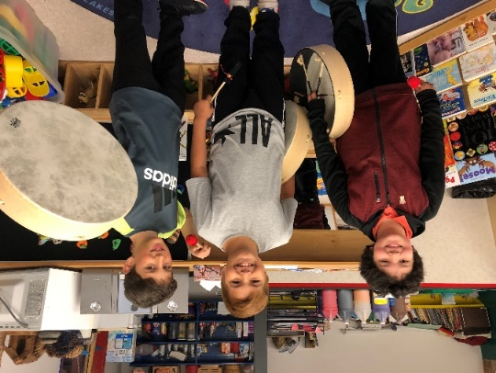
- Many opportunities for parents to come in to the school and share in their child’s learning experience: Cardboard Day Challenge, Christmas Concert, student–led interviews, Halloween Fun Day, field trips, PALS and POPS, Dianna Lake, etc.

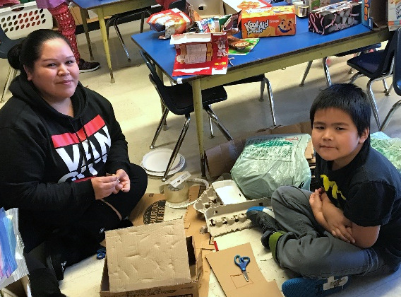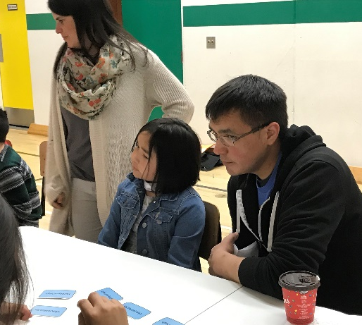
Christmas Cardboard Challenge POPS: Reading
Communication to Parents:
- PAC meetings: includes discussion and consult on important SD issues
- Website, PAC Facebook page
- Student-led interviews, phone calls, E-mail, texting
- Aboriginal Family Resource Worker
- Parents are encouraged to volunteer or attend special events through newsletters, special invitations, synervoice or phone calls.
- School and Community bulletin board by front office

Evidence:
- Benchmarks Reading assessment
- Core Competencies student self-assessments
- Enhancing student learning survey
- EDI: Early Years Development Instrument
- MDI: Middle Years Development Instrument
- ELI: Early Learning Intervention assessment
- Conversations with students, photos, anecdotal observations, student writing, student self-assessments

Reflection and Summary:

We continue to look at how to best support our students in reading. Over the last few years, there is definitely growth in many of our students. Some are showing more than a year’s growth in one year, some more than 2 year’s growth, which is very encouraging! Almost all students are showing some improvement, usually at least 6 months. Others continue to struggle and we will strive to better meet the needs of all our students in this area, particularly those who seem to need something “different” to enable their progress. For a number of the students struggling attendance seems to be a significant issue as well. We are encouraged with the implementation of the Leveled Literacy Intervention (LLI) that we will see continued progress in our younger struggling readers.

Some of the trends noted from the Benchmarks data are:
- 4/5 grades had a higher percentage of students approaching, meeting and exceeding than last year. This is an increase from last year where 3/5 grades had a higher percentage.
- The grade 3’s and 4’s have the highest percentage of students reading at grade level.
- While some students are not yet meeting expectations for their particular grade, it is encouraging that many students made more than a year’s progress in reading overall. In grades 2-5, 73% of students have accomplished this.
- The grade 5 class in particular had 19/21 students who made one year’s growth or more in their reading, which was very impressive! This supports our theory that some students just need more time to develop their reading skills.
- 57% of our grade 1 students are approaching or meeting expectations according to the Benchmarks assessment, but all made progress in terms of their early literacy skills according to the Early Literacy Assessment.
- We are wondering if it is valid to include grade 1 in the section about one year’s growth according to the Benchmarks assessment, since they would basically need to be at grade level to make one year’s progress. Progress can be more accurately measured with the Early Literacy Assessment
- We were happy that we had 18 students (13%) reading above grade level in grades 1-5.

Leveled Literacy Assessment and Intervention (K and gr. 1)
- Kindergarten students were assessed in Feb. and June in the areas of segmenting sounds, rhyming, blending, letter/sound ID, concepts of print, and oral language
- The June assessment shows that there are fewer students at risk in the areas of segmenting sounds, rhyming, blending and letter/sound ID. The same number of students are at risk in the areas of concepts of print (3) and oral language (6) in June as in February. With that many students at risk in oral language, it could be an indication that more work needs to be done with students in this area
- Grade 1 students were assessed in Feb. and June and those at risk were given intervention either one to one or in a small group for approx. 4 weeks
- All students (with a few exceptions) made progress in all of these areas: alphabetical knowledge, concepts of print, phonological awareness, writing and word reading. This is with or without external intervention.
- There are 16/23 (70%) gr. 1 students not at risk (mostly stanine 3 or 4 in the above listed areas) and 6 students at risk, but not necessarily in all of the areas.
- Regardless if the student is still considered “at-risk” according to the Reading Recovery Canadian Stanines, he/she still benefitted from classroom instruction and literacy intervention based on their individual achievement. For example, one student went from hearing and recording 0 sounds in Feb. to 25 sounds in June!

From the surveys and other anecdotal information, it is clear that many students enjoy reading. Based on the data collected from the Enhancing Student Learning Surveys that focussed on reading attitudes, approximately 73 % of students in Grade 1-3 say they like to read books most of the time and 61% of intermediate students say they like reading most of the time. 57% of intermediate students feel they are good at reading. There is still some work to be done around supporting and building students reading confidence, especially in our older grades where students may start to feel self-conscious about their reading if they are not yet reading at grade level. We love to see those students who can’t put a book down!

Through the STEM projects, ADST (including ozobots and spheros), Outdoor Learning, Older/Younger Buddies and School Wide Special Events our students are continuing to develop resiliency in a number of ways: planning and problem-solving, perseverance, collaboration, positive connection to adults and peers, as well as a sense of belonging. The surveys and other anecdotal information indicate that students really enjoy these activities and are becoming very comfortable with them, often able to work on challenges for extended periods of time. They are also beginning to be more competent in explaining their thought process, but this is still a challenge for many.

School trip to Diana Lake

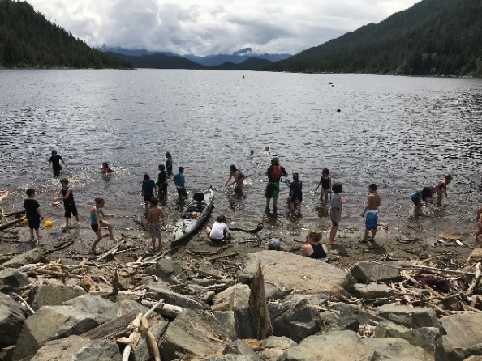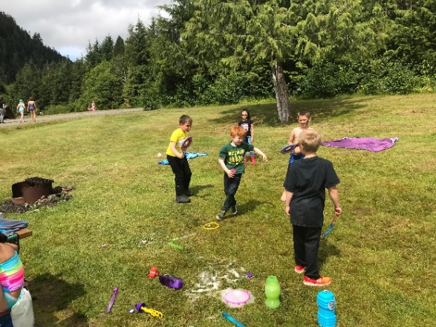

Positive relationships are being built through daily interactions with adults and peers, buddy and collaborative activities, as well as school wide special events. On both the Enhancing Student Learning Surveys (gr. 1-5) and the Middle Years Survey for gr. 4 students (MDI), it was clear that students feel comfortable in their school and feel that there are adults who care about them. Only 2% of students say that they rarely/never feel this way on the ESLS. On the MDI, 95% of students reported they had a positive adult relationship and 88% reported a positive peer relationship.

On the core competency self-assessments, most early primary (gr. 1-2) students feel they are good friends to others, help others and try their best. This is also supported by the ESLS with most (76% all the time and 15% some of the time) gr. 1-3 students reporting they like to do nice things for others. Most intermediate students also report they like to help others.

It was wonderful to see how these kinds of activities provide a greater opportunity for all students to engage in the curriculum and feel successful. Going outside continues to be part of the regular routine for many classes and students are very comfortable being outdoors. Overall, there are fewer issues on the playground as well and students rarely complain about going outside, even if it is rainy!

Although there were many positive outcomes towards our resiliency goal this year, this is an area we will continue to work on. Many students continue to struggle with solving problems independently and give up easily whether it is a social or academic problem. We want to help our students be confident, happy, independent thinkers who persevere.

While many of our students appear to be lacking confidence with problem solving, a large percentage of our intermediate students enjoy activities where they can build or make things. Continuing to work on project based learning with the use of STEM/ ADST will support our learners in enhancing their problem solving skills. The student self-assessments indicate that particularly our older students need to develop more confidence in asking questions, explaining their thinking and persevering when things get tough. This is also about changing students’ mindset about asking questions and making mistakes. Students need to know that it is a good thing to ask questions and that they can learn from their mistakes. Some students commented that they didn’t ask questions because they didn’t want to interrupt the teacher or didn’t want to look “stupid”. We will continue to strive to provide a learning environment where students can develop a growth mindset that allows for them to be confident and thoughtful about their learning.

Next Steps:
- Continue to reflect and revise to best meet the varied needs of our students in terms of reading support, including finding more ways to increase the amount of time students read every day and ensuring those who are struggling have the appropriate support, based on the reading data collected.
- Continue with Level Literacy Intervention for gr. 1 students, begin to look at including gr. 2’s, and introduce the Intensive Phonological Awareness Program (IPA) for kindergarten students.
- Continue with RAISE phonological instruction for primary students and intermediate students who will benefit as well.
- Continue with literacy blocks for primary and intermediate, consider grouping on skill sets, not just the reading level, ie: students reading in the gr. 3 + range needing to work on comprehension could be involved in literature circles
- Continue with our outdoor classroom learning. Perhaps further develop how we can use outdoor education to support our reading goal.
- Continue to explore diverse ways for students to demonstrate their understanding ie: technology, creating/building, oral communication, etc.
- Continue to use hands-on activities and project –based learning that promote student engagement and resiliency.
- Have students become more aware of their learning strengths and needs (growth mindset).
- Be more intentional about having students explain their thinking. Ie: during STEM activities and math problem-solving
- Helping students to be comfortable taking risks, making mistakes and asking questions
- Work with the Speech and Language Pathologist to further develop ways to support our younger students with their oral language ie: co-teaching, language groups, etc.
- Primary teachers working with the Occupational Therapist on ways to develop fine and gross motor skills with our younger students. Teachers have already been working on developing fine motor bins and have met with the OT to develop a plan.

Things to Celebrate 2018-19
Two School Successes:
- Science Fair, Heritage Fair and Bridge Building: These projects were once again hugely successful events, with much effort put in by students and staff. They provide the opportunity for families to become involved in their children’s learning, but some students impressively worked quite independently without a lot of adult help. These are all projects that take great effort and work ethic where students really need to take ownership of their learning. The core competencies of creative thinking, problem-solving, collaboration and perseverance are key. Although the learning journey is not easy, it is well worth it for all when we see the students’ pride and excitement as they share their learning at the different Fairs and Bridge building competition. Many students received awards at the Science Fair, which was impressive! There was also an excellent showing at the Heritage Fair from 2 of our classes in particular with a number of students receiving awards there as well, including three students selected to go the Provincials in the summer! As well, 2 of our classes participated in Bridge Building with awards being won there too!
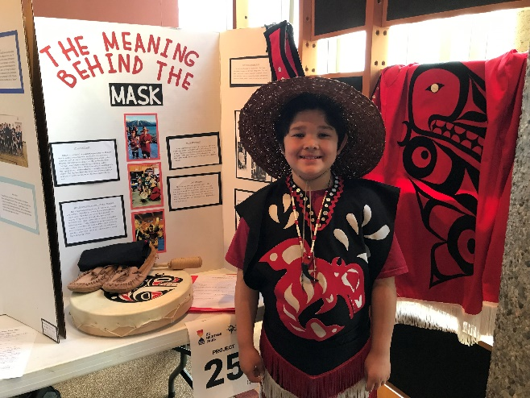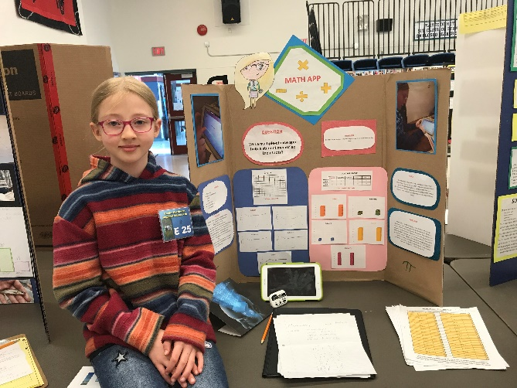
Heritage Fair Science Fair

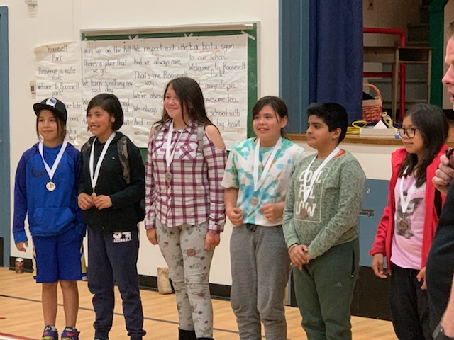

Bridge Building

- Connection to Culture: A number of projects/activities this year helped to develop students’ connection to the local culture. In particular, our Indigenous Peoples’ Day Celebration was a great way for students and staff to come together and participate in activities that develop an awareness and appreciation for our local First Nations peoples. The opening ceremonies started the day with student volunteers sharing about what this day means and our grade 5 class drumming with Ms. Clifton. Then students went on to participate in a number of activities, including art, drumming, stories, Indigenous games, and learning about crests. The morning ended off with some delicious fried bread made by one of our grandparents! It was wonderful to see how engaged the students were.
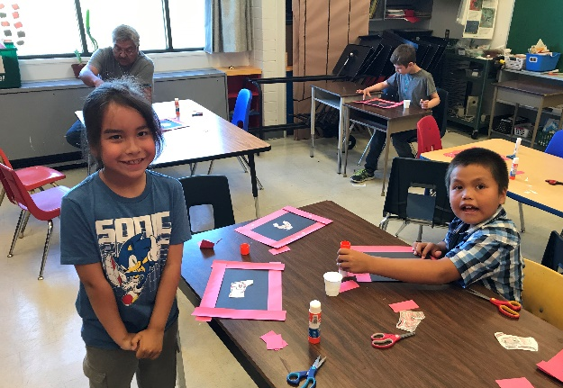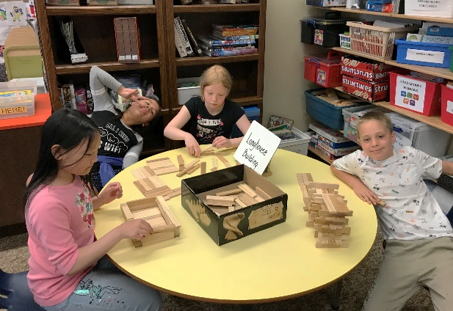
Indigenous People’s Day

A few other related highlights this year were our intermediate Sm’algyax students putting on readers’ theatre plays, complete with sets and props! As well, students learned about cedar weaving and worked with role model, Fanny Nelson on weaving an apron. Also, the staff looked at the resource “The Six Cedar Trees” and how it connects to the core competencies. A number of teachers used this resource effectively in their classroom, noticing how students were able to connect to the different characteristics of the animals. As mentioned above, many of our older students worked on Heritage Fair projects, which gave them the opportunity to research an aspect of their culture, including interviewing at least one person. The projects were wide ranging with grandparent or great grandparent biographies, regalia, farming, fishing, potlatch, and Chinese dancing as just some of the topics. It was great to see the pride and excitement students felt in sharing their projects!

Play performed by Sm’algyax students
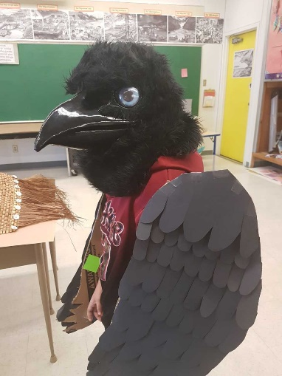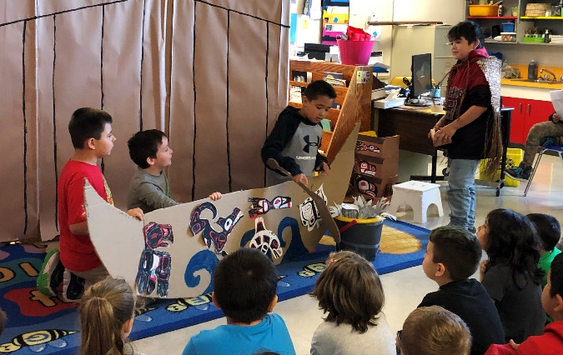
Important School Initiatives: Outdoor Education, embedding STEM projects in everyday learning and special events, Outdoor Classroom Day, self-regulation pathway in the hall.

Memories of 2018-19

Christmas Cardboard Day Challenge
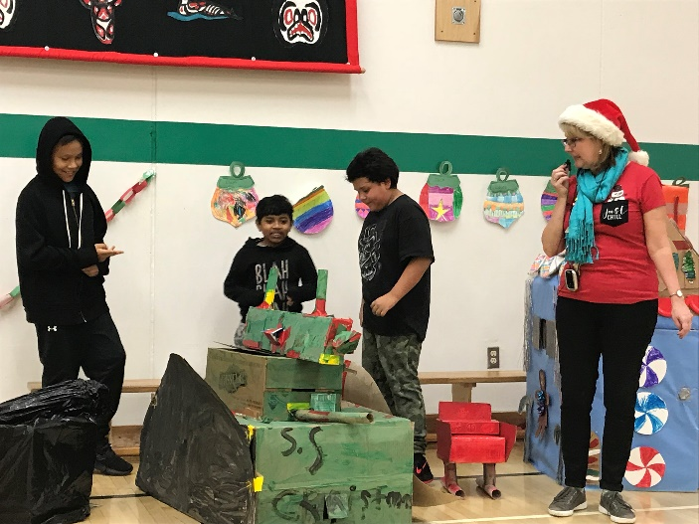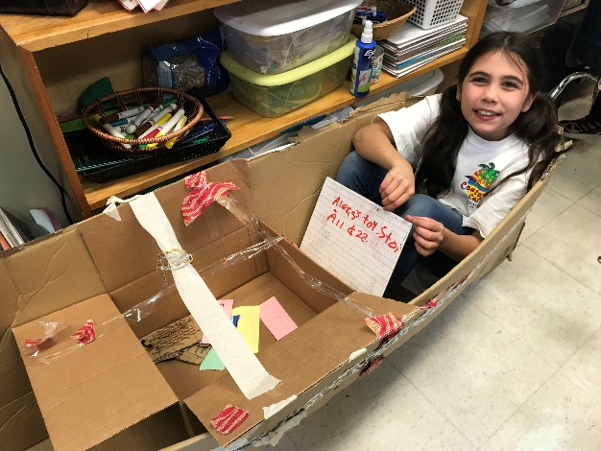
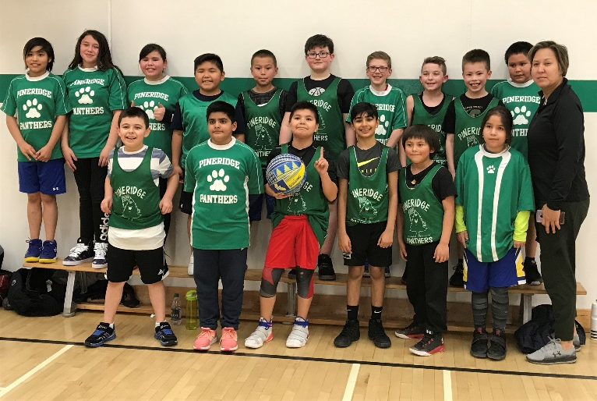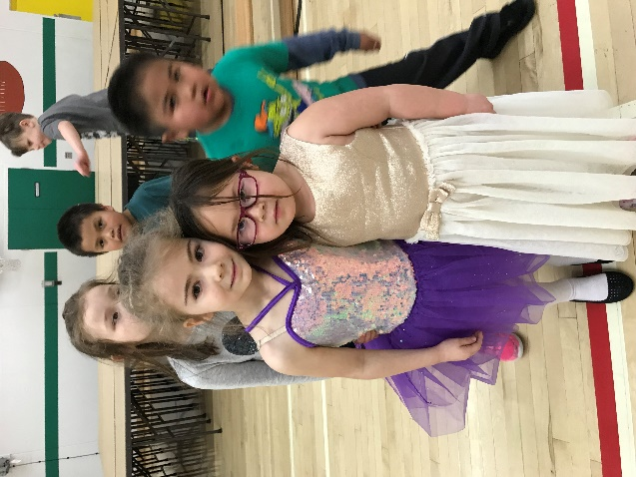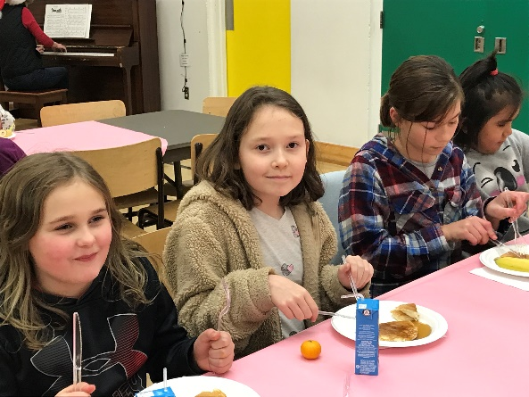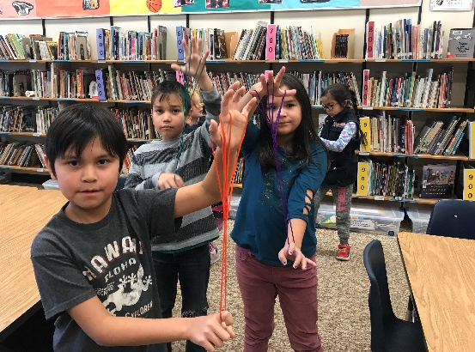

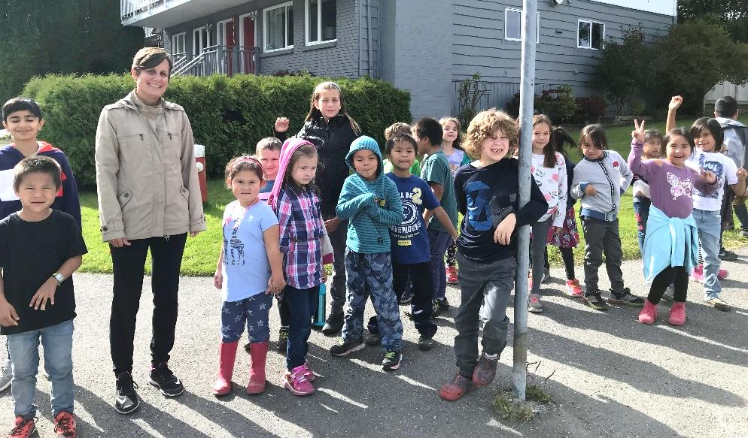
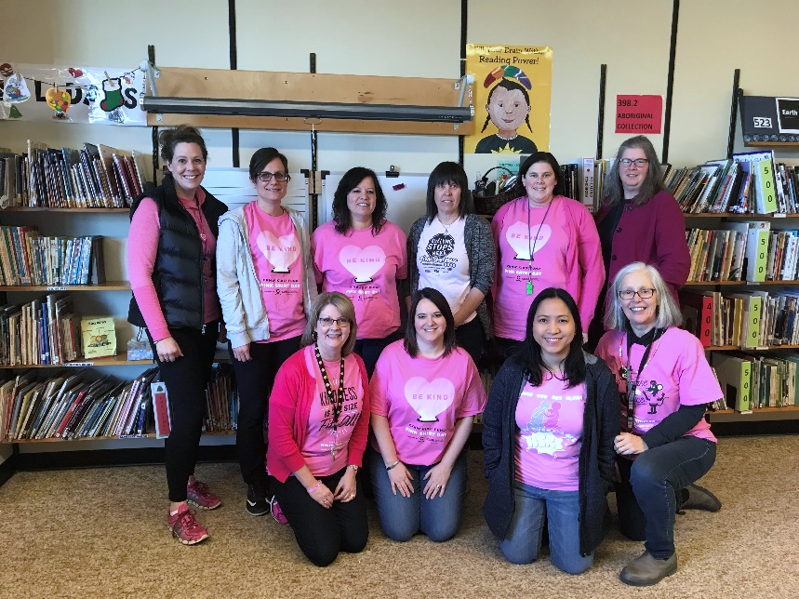
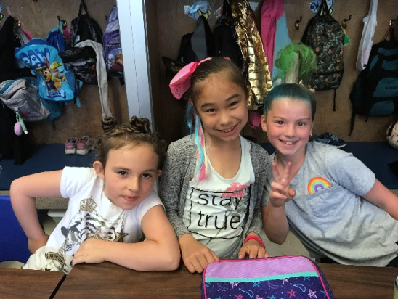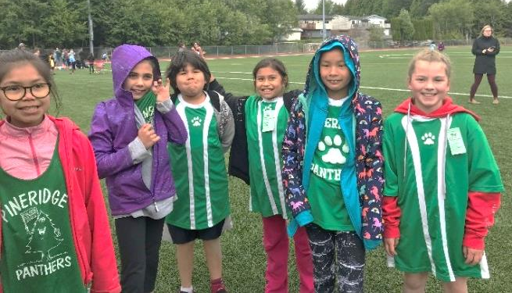

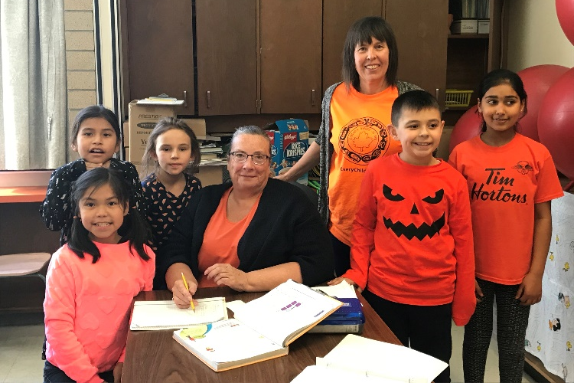It was a Great Year!
Appendix A
Benchmark Reading Data and Survey of Reading Attitudes for School Improvement Plan
Pineridge Elementary School 2018-2019
The literacy focussed goal in our school improvement plan is growth oriented. We looked at the reading abilities of students in the fall and compared those to the results in June. We are aiming for students to achieve one year of reading growth in one year (10 months of instruction). This is our fifth year of running literacy blocks, having regular assessments of reading (three times per year) and guiding instruction by the assessment. We have also included Benchmark reading data from the past 3 years. As well, information about students’ attitudes towards reading is included to support the secondary part of the reading goal, which is to develop a love for reading.
Reading Attitudes
(From Enhancing Student Learning Survey in October 2018)

Grade 1-3
Total surveyed: 73 students (approx.)

Statement: | Most of the Time/always | Sometimes | Rarely/Never
I like to read books. | 53: 73% | 15: 20% | 5: 7%

Grades 4-5
Total surveyed: 60 students (approx.)

Statement: | Most of the Time/always | Sometimes | Rarely/Never
I like reading. | 37: 61% | 19: 31% | 5: 8%
I am good at reading. | 34: 57% | 23: 48% | 3: 5%
I read to find things out. | 29: 49% | 26: 43% | 5: 8%
I read for fun. | 30: 51% | 22: 37% | 7: 12%

Number/Percentage of Students Showing at Least One Year’s Growth in Reading
(Benchmarks Assessment)

The final number in each column shows the percent of students that have made at least one year of growth in their reading skills, according to the Benchmarks assessment.

Grade | 2014-15 | 2015-16 | 2016-17 | 2017-18 | 2018-19
1 | 11/35: 31% | 15/31:  48% | 15/28  54% | 3/18  2% | 5/23  22%
2 | 13/39  33% | 20/34  59% | 16/34  47% | 18/30  60% | 14/21  67%
3 | 17/32  44% | 28/39  71% | 18/34  53% | 20/31  65% | 17/28  61%
4 | 16/30  53% | 17/30  57% | 24/36  67% | 13/35  37% | 19/25  76%
5 | 12/28  42% | 25/29  86% | 20/34  59% | 9/37  24% | 31/37  84%

Number of Students Making at Least 1 Year’s Growth (Benchmark’s Reading Assessment)

Number/Percentage of Students Approaching/Meeting/Exceeding Grade Level
(Benchmarks Assessment)

We also looked at reading results at the end of the year to determine how many students are reading at grade level and how many are almost reading at grade level:

 | 2015-16 |  | 2016-17 |  | 2017-18 |  | 2018-2019
 | ME | AE/ME/EX | ME | AE/ME/EX | ME | AE/ME/EX | ME | AE/ME/EX
Grade 1 | 7/31  23% | 16/31  52% | 10/28  35% | 16/28  57% | 3/18  17% | 4/18  22% | 5/23  22% | 13/23  57%
Grade 2 | 13/34  38% | 20/34  59% | 9/34  26% | 18/34  53% | 16/30  53% | 17/30  57% | 7/21  33% | 13/21  62%
Grade 3 | 17/39  44% | 27/39  69% | 13/34  38% | 14/34  41% | 13/31  42% | 17/31  55% | 13/28  46% | 18/28  64%
Grade 4 | 12/30  40% | 20/30  67% | 9/36  27% | 26/36  72% | 12/35  34% | 19/35  54% | 10/25  40% | 19/25  76%
Grade 5 | 18/29  62% | 24/29  83% | 7/34  21% | 16/34  47% | 13/37  35% | 25/37  68% | 11/36  31% | 17/36  47%

AE- Approaching Expectations
ME- Meeting Expectations
EX-Exceeding Expectations
This year, we have 18/138 students exceeding expectations, which is 13%.
Note: 6 students were not included in this data. These students have significant learning exceptionalities and the Benchmarks Reading assessment is not appropriate for them.

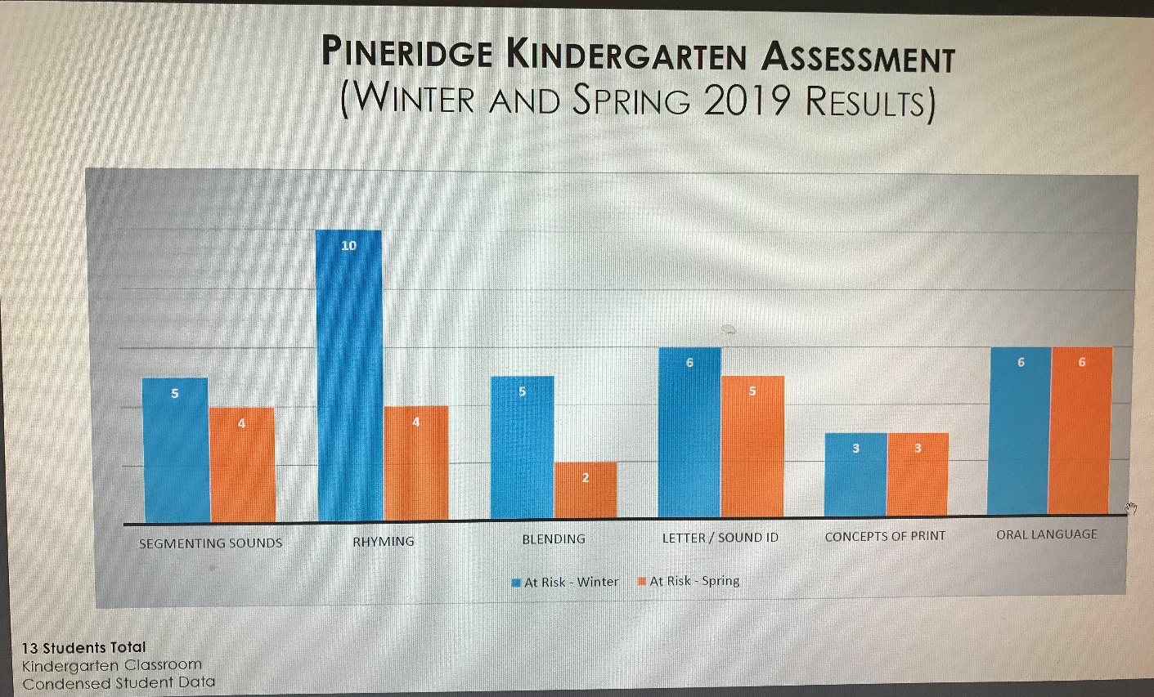

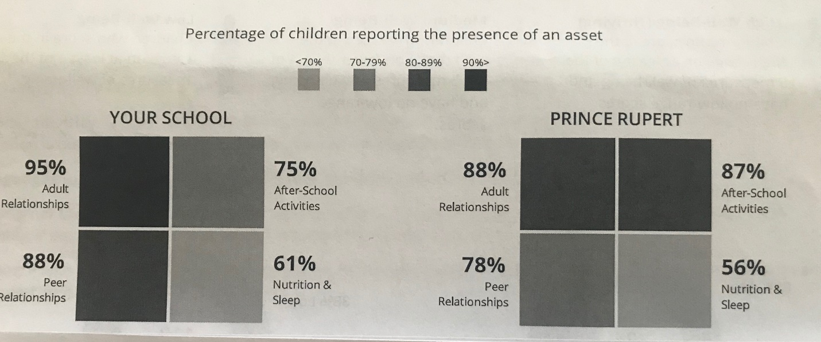
Taken from Pineridge MDI Report 2018-19
(“An asset refers to positive experiences, relationships or behaviours present in children’s lives”)

Appendix B
Goal #2 Data: Student Self Assessments
Students, with teacher support, completed self-assessments in June for the Core Competencies. Different grade levels completed assessments appropriate to their age. The competency statements that seemed particularly pertinent to our resiliency school goal have been tallied below.
Early Primary (Gr. K-1) (30 students)
 | Most of the Time | Sometimes | Rarely/Never
I am always a good friend | 25 | 5 | 0
I try my best on all of my work. | 23 | 8 | 1
I ask questions. | 15 | 10 | 6
I don’t give up when things get tricky. | 22 | 5 | 3
I help others. | 27 | 3 | 0

Early Primary (Gr. 1-2) (32 students)
 | Most of the Time/Always | Sometimes | Rarely/Never
I am a good friend to other students. | 27 | 5 | 0
I help others | 25 | 7 | 0
I use my WITS | 19 | 11 | 2
I ask questions. | 21 | 11 | 0
I don’t give up when things get tricky. | 25 | 7 | 0
I try my best | 28 | 2 | 1

Late Primary/Intermediate (Gr.3-5) (72 students)
 | Most of the Time/Always | Sometimes | Rarely/Never
I can explain my thinking | 13 | 35 | 24
I ask questions | 23 | 27 | 22
I don’t give up | 22 | 26 | 17
I am kind and caring | 33 | 27 | 8

Goal #2 Data: Enhancing Student Learning Surveys from October 2018 and May 2019
In the fall, students completed a survey related to the goals of the Enhancing Student Learning Document. Below are the results of the statements related to resiliency.
Grade 1-3
Total surveyed: 71 students

Statement: | Most of the Time/always | Sometimes | Rarely/Never
I like to do nice things for other people | Fall Spring  56: 79% 59: 76% | Fall Spring  13: 7% 12: 15% | Fall Spring  2: 3% 7: 9%

Grade 4-5
Total surveyed: 57 students (approx.)

Statement: | Most of the Time/always | Sometimes | Rarely/Never
I enjoy activities where I can solve problems. | Fall Spring  32: 55% 33: 58% | Fall Spring  22: 38% 19: 33% | Fall Spring  4: 7% 5: 9%
I enjoy activities where I can build or make things. | Fall Spring  44: 86% 49: 83% | Fall Spring  6: 12% 7: 12% | Fall Spring  1: 2% 3: 5%
I do kind things at my school without being asked. | Fall Spring  35: 63% 29: 48% | Fall Spring  21: 38% 29: 48% | Fall Spring  0: 0% 2: 3%
I like helping others. | Fall Spring  47: 82% 43: 70% | Fall Spring  10: 18% 18: 30% | Fall Spring  0: 0% 0:0%
There are adults at school that care about me. | Fall Spring  46: 81% 48: 80% | Fall Spring  11: 19% 11: 18% | Fall Spring  0: 0% 1: 2%
I see myself reflected in my school. | Fall Spring  39: 67% 31: 52% | Fall Spring  17: 29% 24: 40% | Fall Spring  2: 3% 5: 8%
I feel comfortable in my school. | Fall Spring  44: 77% 49: 80% | Fall Spring  10: 17% 11: 18% | Fall Spring  3: 5% 1: 2%

Appendix C
School Beliefs

Pineridge School Beliefs
We keep our school safe and caring
We show kindness to each other
We include everyone and we don’t tolerate bullying
We follow the school rules
We respect ourselves, each other and the environment
We respect others’ belongings
We respect others’ personal space
We respect our school building, property and natural surroundings
We are polite, active listeners who respect others’ ideas
We respect and celebrate differences
We speak respectfully to adults and peers
We play fair and take turns
We take responsibility for our learning
We participate and try our best
We use self-regulation strategies
We work at solving problems and don’t give up!

Learning is fun, active and engaging!

