Charles Hays Secondary School Plan for 2019-2020
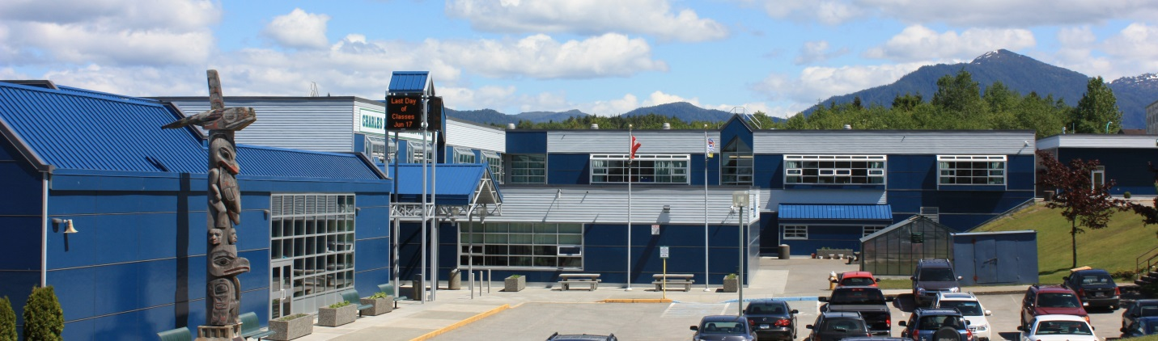
Vision Learning and Working Together
Apprendre et Travailler Ensemble
Sagayt Suwilaawksa Ada Hakahalels
Mission
To ensure every student successfully completes his or her educational program.
Context
Charles Hays Secondary School (CHSS) is a grade 9 – 12 high school located in the City of Prince Rupert on traditional Ts’msyen territory. The school has a diverse multicultural population including 60% students of Aboriginal ancestry. Our enrollment has been declining slowly and was 620 on September 30, 2018. CHSS is a dual track school with a French Immersion Program and offers Sm’algyax and French as second language courses. The school has a strong academic program, a growing trades program, a vibrant fine arts program and a hockey academy.
We moved to a Trimester Timetable in September 2018. We believe the timetable will allow us to adapt to BC’s New Curriculum and provide more flexibility for teachers and students. We will be working on determining what kind of data we need to collect to assess the value of the changes we have made.

Goal(s) (Long term and framed as an inquiry)
If we identify students who are experiencing difficulty with aspects of their learning, offer supports and intervene, will we see an improvement in achievement for all learners?

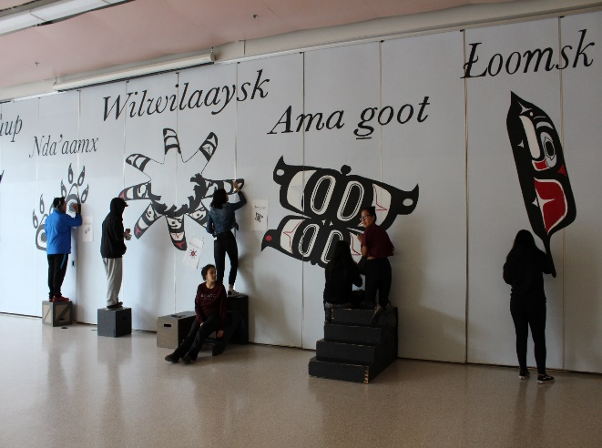
- Will we see an improvement in the number of Grade 9 students who transition into Grade 10 core courses as evidenced by report cards?
- Will we see an improvement in our graduation rate for all learners with a particular focus on a 6 year graduation rate as evidenced by graduation data?
- Will we see a narrowing of the gap for our Aboriginal students?
- Will the Trimester system make a difference and how?
Structures and Strategies – What things are in place to help us meet our goal?
We are fortunate to have many staff members who play a supporting role at CHSS. Working alongside, they help build connections, relationships and trust with staff and students. These are our;
- Counsellors
- Learning Services Teachers (LSTs)
- Education Assistants (EAs)
- Aboriginal Support Workers (ABRWs)
- Secretaries
- Library Assistant
- Custodians

There are structures in place that provide strategies and options to support learning for all students.
- The Library Learning Commons (LLC) along with Room 204 provides a space for students with support blocks and those who are enrolled in Moodle Courses.
- Peer Tutors receive credit as they provide support to other students. Peers are very effective and relevant peer teachers.
- The Greenhouse Project is a continuing project used mainly by the Foods and Science Departments. The project provides experiential learning opportunities, the chance to make community connections as well as providing food for the Breakfast and Foods Program.
- Our Breakfast and Lunch Programs are important structures that ensure learning is not impeded by hunger.
- FLEX is a new addition that provides students with the opportunity to keep up with their class work as well as to spend time working on areas of interest and passion.
- Weekly, Thursday morning meetings of the support team help us identify and support students we are concerned about in terms of attendance, or progress.
- Bus passes are available for students who have a hard time getting to school as long as they are attending.
- Collaboration Time allows staff to work together on initiatives, projects, and implementing the new curriculum in their departments, and across the curriculum.
- Our students each have a MyBlueprint.ca account. This Canadian Careers website gives them access to Canadian colleges and universities as well as Canadian career information. Students can access it at home as well as at school.
- We offer a wide variety of courses based on the interests of our students like Musical Theatre, Basketball, Youth Exploring Trades, Photography, Band, Guitar, Foods, Textiles, Tech Ed, Art, Photography, Business and Languages.
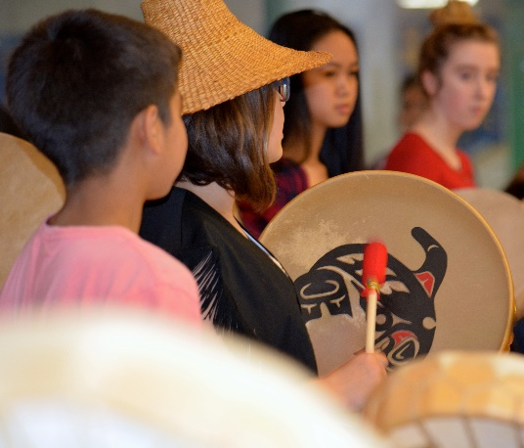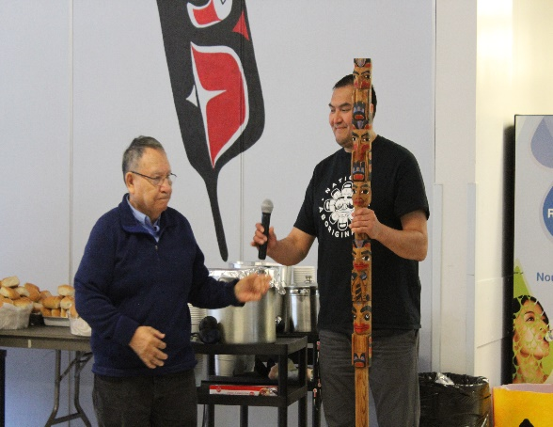

Plans for Staff Development – When and What?
Our staff members participate in many Professional Development opportunities every year. Many attend specialized Professional Development Conferences (PSAs) and a number are working on their Masters in Education. This next year our Math 9 teachers will be invited to continue the work in our District to support Numeracy. In 2018-2019, we were fortunate to work alongside educators like Carol Fullerton (Numeracy) and Faye Brownlie (Literacy) and hear from Pia Escadero on Trauma Informed Practice.
Plans for staff development in the future will include the following:
- Continued work towards supporting teachers with inclusive practices.
- Continued work on implementing the New BC Grade 10 – 12 Curriculum.
- Supporting the Math 9 teachers in the continued work on strategies, and assessments that support Numeracy.
- Strengthening our FLEX blocks.
- Continued work on developing Career courses that are relevant and encourage students to take ownership of their learning.
- Continued reflection on assessment practices in anticipation of the New Reporting Order.
- Providing Collaboration Time that allows staff members to work together on professional development as well as the collaborative development of units and projects.
- Continued work on improving School Culture.
Community Involvement – How does communication with stakeholders support the goal?
Parents and Guardians participate in parent/teacher interviews, sports events, fine arts performances, fund raising events and Parent Advisory Council meetings. We continue to look at ways to partner with parents and the community to make attendance a community focus. We believe it will impact and benefit our community in the long term by creating socially responsible citizens.
Community members are often guest speakers in many departments and often provide Career Awareness for our students.
Our School Plan is shared with students, teachers, education assistants, and parents and it is posted on the CHSS and School District 52 websites.
Evidence –demonstrating school success in meeting the goal or not
Transition Data
The trend has always been towards less and less students transitioning to the next grade as they move from Grade 9 through to Grade 12. We were pleased to be in the first cohort of 10 schools in British Columbia working on a Province wide Transitions Inquiry with the AESN. Our Transitions Learning Feast (Lu’ulgit) has been held the past three years to create connections to the school for the Grade 8 students. The staff and students who were involved in preparing, presenting and serving at the Feast expressed how impactful it is for them. Each year we interview the incoming Grade 9s to assess whether the Feast helped them to feel welcome at the high school with very positive responses.
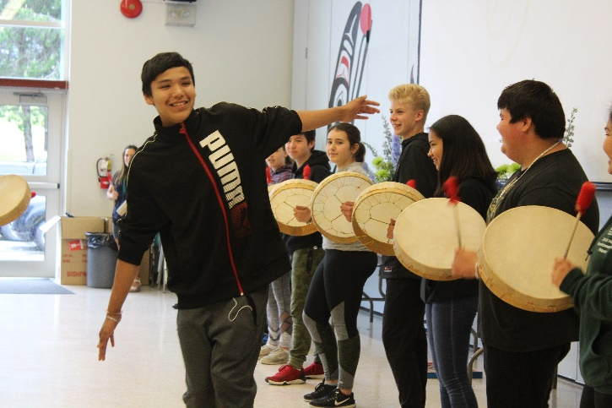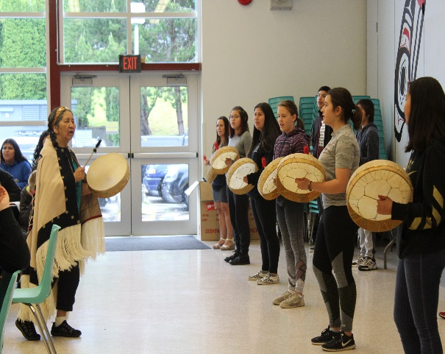

Transitions Data for School District 52 As per studentsuccess.gov.bc.ca (June 2019)
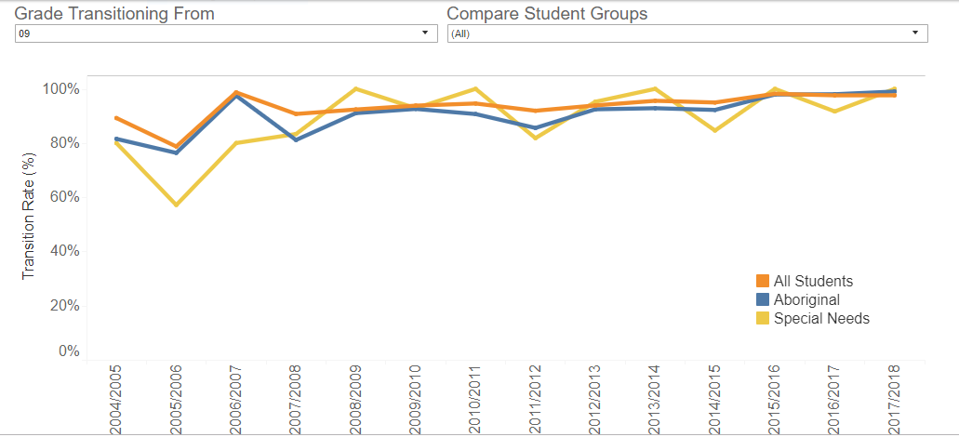
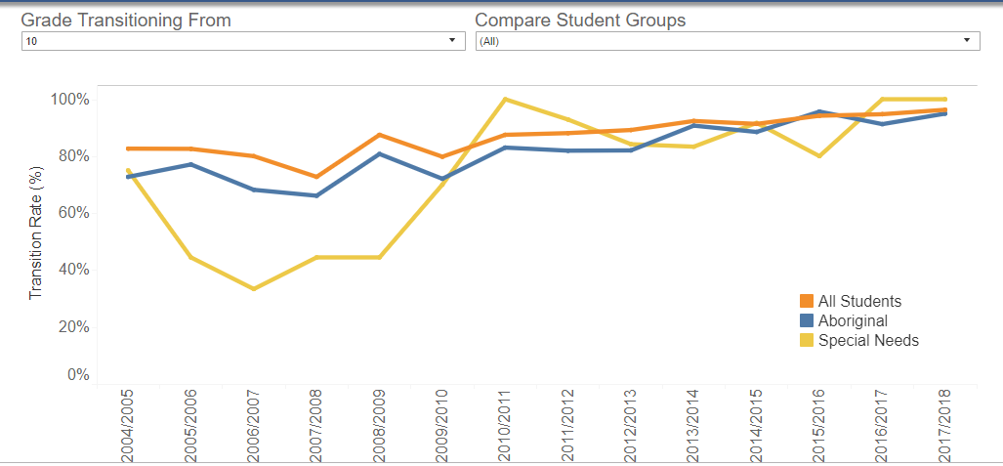
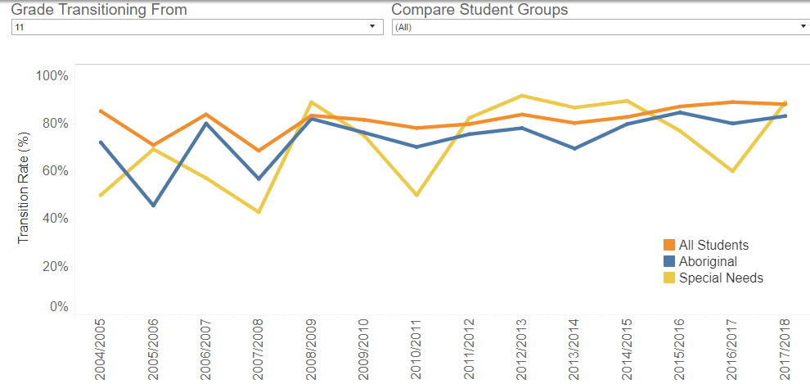
In Grade 9 and 10, we are close to parity for students transitioning into Grade 10 and 11. We have work to do to improve parity for students transitioning into Grade 12.

Grad Data
We are very pleased to see our 6 year graduation rate is holding for all students. We are mindful that each cohort of students is unique and with a smaller student population we will see more fluctuations. We are pleased with the trend in improved achievement but still seek parity for our Aboriginal and Non-Aboriginal students.
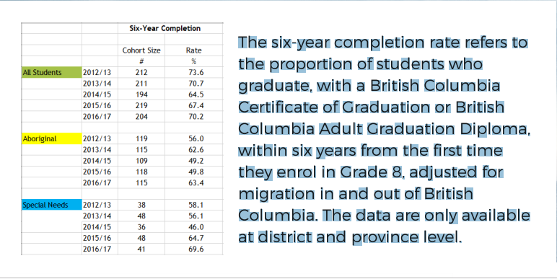

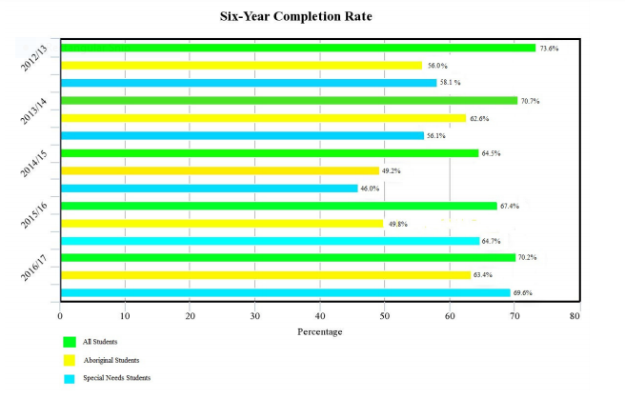
-Taken from Framework for Enhancing Student Learning, 2018, Prince Rupert SD 52

This data is found on the studentsuccess.gov.bc.ca website and includes Pacific Coast School.
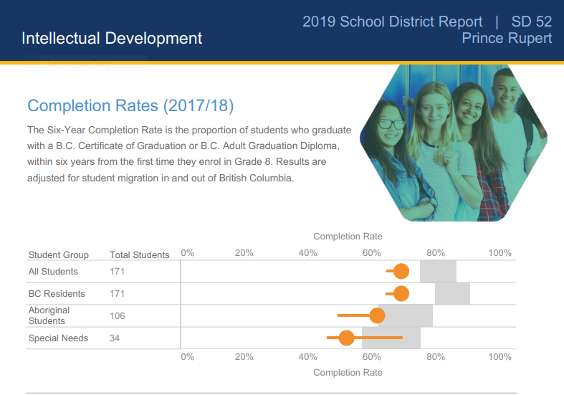
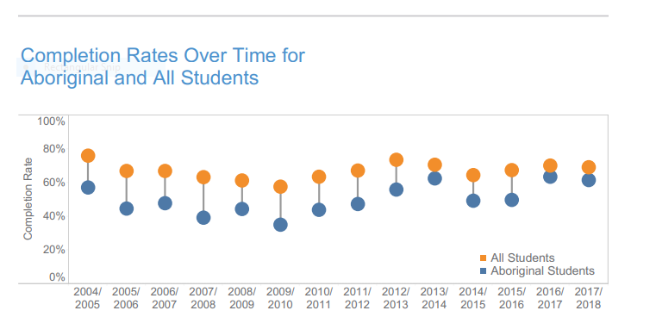

This data shows the progress of our current graduating class. The data includes students at Pacific Coast School.
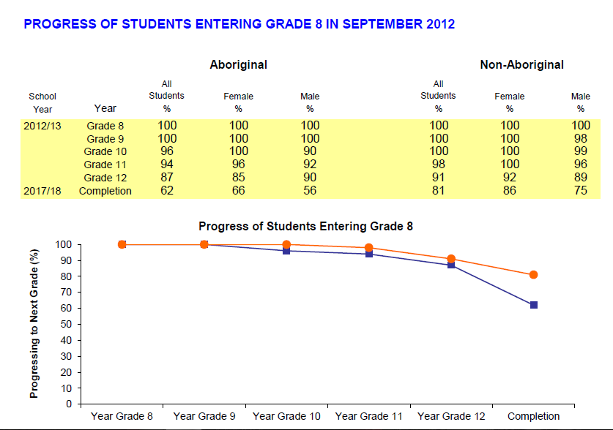
Moodle Data
This was our 3rd year providing Moodle courses for students at CHSS. This year students were enrolled in 19 different courses. We believe that most students will learn better in a classroom with a teacher and with their peers. However, Moodle provides students another option when they are struggling with a course so they can work at their own pace. The Moodle courses allow us to keep students, who otherwise would have fewer or no classes, in the school.
Library Learning Commons - Moodle Courses
School Year | 2016-2017 | 2017-2018 | 2018-2019
Students enrolled in courses | 98 | 90 | 62
Courses Completed | 32 | 44 | 21
Courses Continuing | 6 | 10 | 15
Courses Removed | 60 | 36 | 26

Attendance Data

We are clarifying our attendance policy because we believe that attendance is key to ensuring students are successfully completing their courses.

Reflections and Next Steps
Charles Hays Secondary School continues to provide some amazing opportunities for our students and we will continue to build and add to what we offer our students. Our Extracurricular clubs and teams add so much to what we offer at the school and help our students to grow intellectually, physically and emotionally.
We look forward to working in the following areas to improve learning for every student at our school:
- Creating clearer policy around attendance
- Updating our Code of Conduct and clarifying expectations
- Continued work on improving communication by listening, and by encouraging positive and solution based feedback to challenges
- Making changes to FLEX time that make it more effective
- A plan for a community attendance focus is something we still want to actively pursue
- Work on ways to improve communication with parents and guardians, starting with an earlier Open House in September
- Continue to build on our technology and find ways to teach and learn about how to use it effectively for learning
- Help students set their goals for graduation earlier through our new Careers courses and MyBlueprint.ca
- Incorporating First People’s Principles of Learning across the curriculum.
- Looking a what types of data will give us evidence that the trimester system
Next year, we look forward to the opening of our new Library Learning Commons and involving as many students as possible in the Totem Pole Project with carver Russell Mather.

