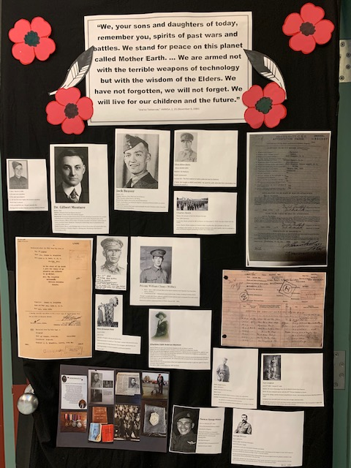
Leading up to Indigenous Veterans Day, November 8th, students in Tianna Wright’s grade 6 class at PRMS and students in Danielle Dueck’s grade 11/12 Social Justice class, researched the role of Indigenous veterans in both World Wars. Tianna Wright investigated Tsimshian World War I veterans at our local archives and was able to find a wealth of information that she was willing to share. Curriculum Specialist Lauren Neiser, collaborated with teachers and students and helped provide them with additional resources and learning opportunities and also contributed to the Remembrance Day assembly with a piece on Indigenous Veterans Day.

