Port Edward Community School Plan

2019-20

|  |  |
| --- | --- |
| **Vision:** | Using the rewards of a small, multi-age classroom model, Port Edward Community School endeavors to meet the unique needs of the community and its students through an approach that enhances the development of the Core Competencies. |
| **Mission:** | Our mission is to improve student achievement by encouraging all members of our school community to engage in learning, strive for personal excellence, and furnish a safe environment for all. |
| **Beliefs:** | Instruction matters. Our students are valuable, can be successful and must be supported in all ways. School community partnerships enhance learning for all students. The staff has a crucial role in the success of our students. |

**Context:** Port Edward Elementary School is located in the village of Port Edward (2016 pop. 467). The municipality is located 15 kilometers from the City of Prince Rupert (2016 pop. 12,220). The school is part of School District No.52, which is located on traditional Ts’msyen territory and has a Partnership Agreement with the local Aboriginal community that has existed since October 2001. A new school building opened on January 7, 2013, which was adjoined to the municipal office to accommodate declining student enrolment, a trend that has continued. This year, there is one class, K through 5, with 11 students.

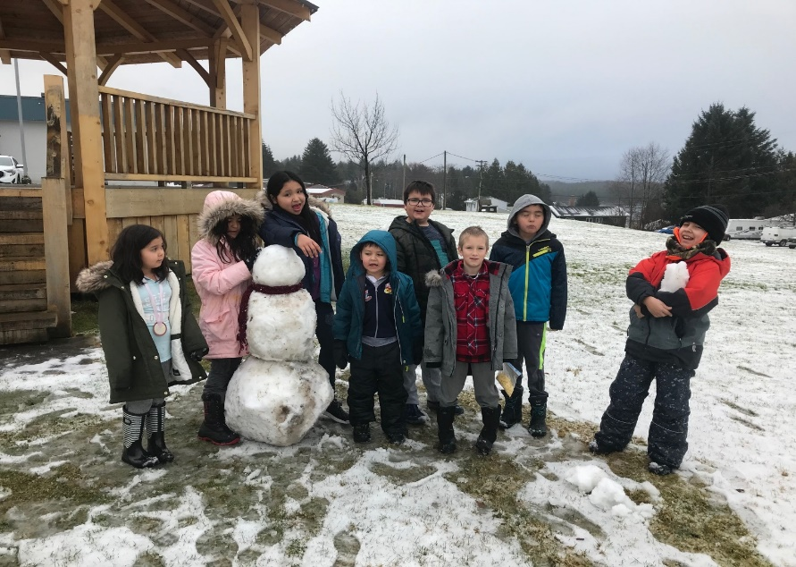

**Goal**:

* **Will changes in our instructional practice cause changes in academic achievement in literacy, math and social/emotional learning for our students?**

**Structures and Strategies**:

* Alphabet letter and sound recognition, sight word assessment for K/1s, BC Performance Scales for Gr.2-5 writing.
* Leveled Learning Instruction taught for K-1 students
* Employing math instruction used and taught by Carole Fullerton.
* iPad use supports Coding; Math IXL and other programs promote familiarity with technology.

**Plans for Staff Development**:

* Attend Barb McBride literacy training
* Attend Carol Fullerton workshops to enhance math practice and student achievement.
* Connect with Aboriginal Education Committee/Wap Sigatgyet on Aboriginal Ways of Knowing.
* Work with the teacher, educational assistant, and district staff to promote consistency of language, instruction and supports.
* Continued work to improve literacy skills and student independence through the use of programs like Daily Five, *Reading Power* and make use of the Leveled Literacy Instruction kit.

**Community Involvement:**

* Collaboration and involvement with Conrad School partners on school-wide educational activities like the Halloween Fun Day, String Stories and Christmas Art Activities.
* Visits to and from the Port Edward Volunteer Fire Department, North Pacific Cannery, Court House, Conrad School, Museum of Northern BC, Skeena River and more.
* Parent Advisory Committee involvement in activities such as theme days, outdoor education, financial support of school activities such as swimming lessons, and support in improving communication with parents and guardians.
* Reading with the Rampage
* Salmonids in the Classroom with the Dept. of Fisheries and Oilfield Creek Fish Hatchery.
* Enrolment in the Breakfast Club of Canada, Agriculture in the Classroom, and the BC Milk program.

**Communication:**

* Plan and school goals/achievements communicated through an open door policy, Twitter, website, parent evenings, newsletters and direct parent/guardian contact.
* Parent/teacher interviews.
* School events- Winter Concert, Sm’algyax Fun night and Year End Barbeque

**Evidence**:

* Student artifacts, anecdotal reports, report card data, Benchmarks.

**Port Ed Data 2018 – 2019**

1. English Language Arts Grades K - 5
2. Math Grades K - 5



**Reflection and Summary:**

* 2018-2019 year began with a new teacher and a new principal but were accepted into the community. Being essentially a rural, one-room, multi-age school provided us with the flexibility to address both the unique characteristics of our students, and implement elements of the New BC Curriculum with a small, but diverse group. Inclusivity was a key component of the staff’s approach, as was taking advantage of learning opportunities off-site whenever possible. Continuing the collaboration with Conrad Elementary and Port Edward Schools was a positive experience. Not only did Port Ed attend Conrad for school-wide events, but a class at Conrad visited Port Ed a few times and went on a number of field trips with them. Student interaction with new peers and the ability for staff members to collaborate were benefits for both groups.
* We were pleased to take advantage of the flexible nature of our site. We explored the new parks in Port Edward, North Pacific Cannery, Port Edward Fire Department, and participated in outdoor learning experiences at the pond in Port Ed, Skeena River, Diana Lake, and Kloiya Bay. In Prince Rupert, we visited the court house, Sunken Gardens, Whalefest, the Museum of Northern BC, and took swimming lessons at the pool.
* Port Ed School had a cooking program this year where students learned recipes and were able to learn about measuring and ways on preparing and handling food. They were also able to eat together and on occasion invited special guests out to share food them (Superintendent, Principal, Director of instruction, and Parents.)

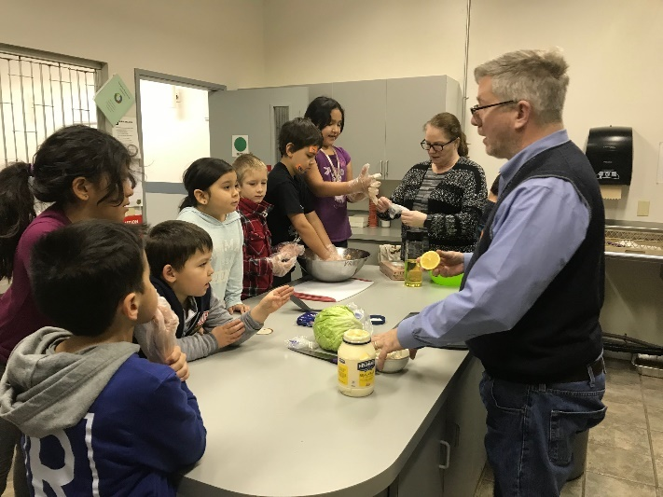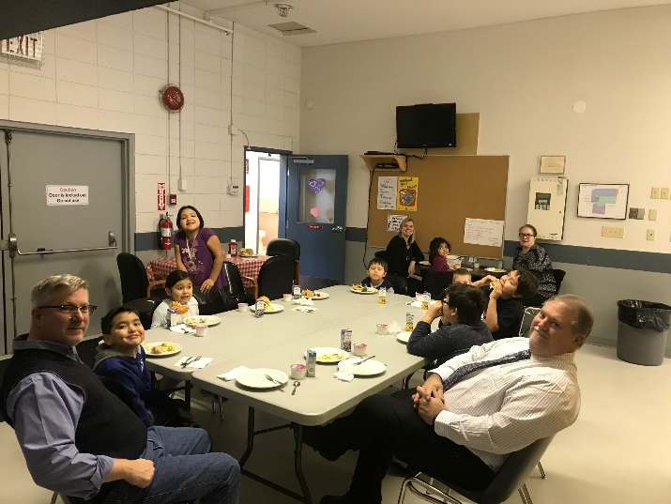

**Next Steps:**

* We will continue our work on implementation of the new BC Curriculum, Core Competencies, Applied Design, Skills, and Technologies and Coding.
* We will continue to seek out opportunities to participate in events with other schools and Aboriginal Education to strengthen bonds and programs.
* We will continue to improve our literacy and numeracy scores using programs such as those set out by LLI, Daily Five, Adrienne Greer and Carol Fullerton.
* Continue the efforts made to connect students to the environment and outdoor education opportunities.
* Continue to learn recipes and real-life math through the cooking program.

**Things to Celebrate**

* Important School Initiatives:

* + Collaboration with Conrad Elementary School. Our school joined with Conrad School on several activity days, and our teacher joined forces with staff from the school. Participation in these events was a bonus for our students, who were able to connect with students from an in-town school, and be a part of a larger peer grouping, which paid social/emotional benefits.
  + Continue with the Cooking Program.
  + Continue with Outdoor and place-based learning

